24ADI004 — DATA SCIENCE AND VISUALIZATION
TEAM 02 | WEEKLY PROJECT REPORT

Global Life Expectancy Paradox
"Does wealth truly buy a longer life?"

Name | Roll Number
Dhivya A | 24BAD020
Harshavarthan S B | 24BAD033
Jaya Krishna G | 24BAD042
Lathika M | 24BAD062
Objective
To analyze how economic factors (GDP), social indicators (schooling), and health system components (immunization coverage) jointly influence life expectancy across countries, with special attention to patterns of missing and inconsistent data prevalent in developing nations.
Executive Summary
This project explores the paradox between national wealth and population health outcomes using the WHO Life Expectancy dataset. The dataset spans 193 countries and 16 years (2000–2015), covering 22 variables that capture health, economic, and social dimensions. Each week of this project contributes a distinct analytical stage — from raw ingestion and cleaning through exploratory analysis, feature engineering, and dimensionality reduction — building a complete and reproducible data science pipeline.
SDGs Addressed
- SDG 3 — Good Health and Well-Being
- SDG 4 — Quality Education
- SDG 8 — Decent Work and Economic Growth
- SDG 10 — Reduced Inequalities
Dataset Overview
Attribute | Detail
Source | World Health Organization (WHO) — Kaggle Datasets
Link | https://www.kaggle.com/datasets/kumarajarshi/life-expectancy-who
Type | Country-wise, yearly panel data
Rows × Columns | 2,938 rows × 22 columns
Year Range | 2000 to 2015
Countries | 193 unique countries
GitHub | https://github.com/varthanharsh35-ux/24ADI004_TEAM-2.git

WEEK 1
Team Formation, Environment Setup & Data Ingestion

1.1 Team Formation & Problem Selection
The first week was dedicated to team formation, identifying each member's technical strengths, and selecting a meaningful research problem. After reviewing several publicly available datasets related to public health, economic inequality, and education, the team selected the WHO Life Expectancy dataset from Kaggle because it combines economic, social, and health dimensions across a 16-year global scope.
The finalized problem statement was: Does wealth truly buy a longer life? This statement was chosen because it directly challenges the assumption that GDP alone determines health outcomes, opening space for multifactorial analysis.
1.2 Theoretical Background — Data Ingestion
Data ingestion is the process of importing data from a source into a working environment for processing and analysis. In Python, the pandas library provides read_csv() as the primary tool for loading tabular data from comma-separated files. A critical but often overlooked step is stripping whitespace from column names, as the WHO dataset is known to contain trailing spaces that cause KeyError exceptions during column access.
The initial inspection phase — checking shape, dtypes, head/tail rows, and memory usage — is standard practice in any data science pipeline. It establishes a baseline understanding of what data is available before any transformation occurs.
1.3 Libraries Used
Library | Purpose
pandas | Data loading, manipulation, and tabular operations
numpy | Numerical computing and array operations
matplotlib | Low-level plotting engine and chart customization
seaborn | High-level statistical visualization built on matplotlib
sklearn | Machine learning preprocessing: scaling, PCA, encoding
scipy.stats | Gaussian KDE for smooth density estimation in plots
warnings | Suppress non-critical runtime warnings

1.4 Code — Library Import & Style Configuration
Code:
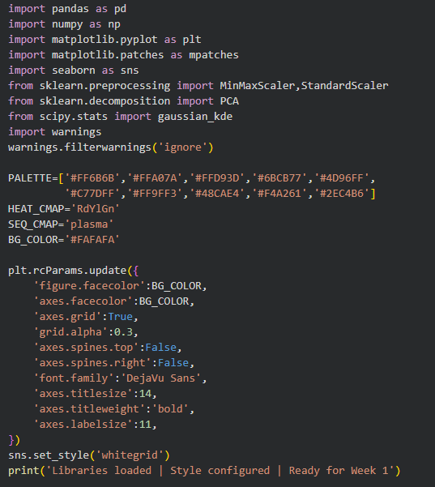

Output:
What This Output Tells Us
A single confirmation line is printed when all libraries load without errors, verifying the environment is fully configured. The PALETTE list defines ten consistently-used chart colors throughout the project, ensuring all visualizations share a unified aesthetic. The rcParams block standardizes background color, grid visibility, and axis styling globally, so no manual formatting is needed per plot.

1.5 Code — Data Loading
Code:
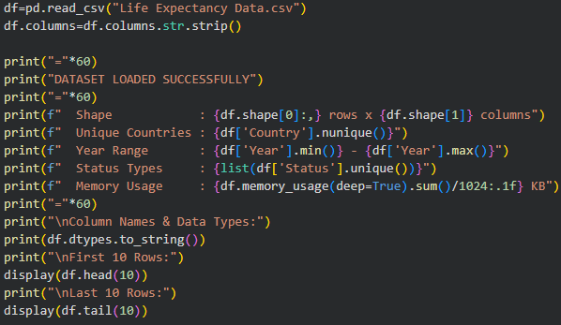
Output:
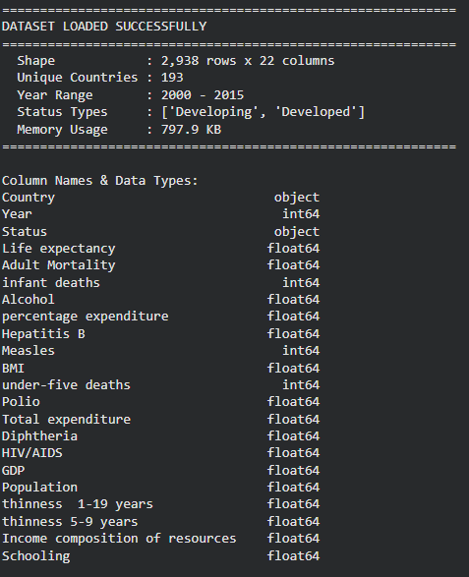

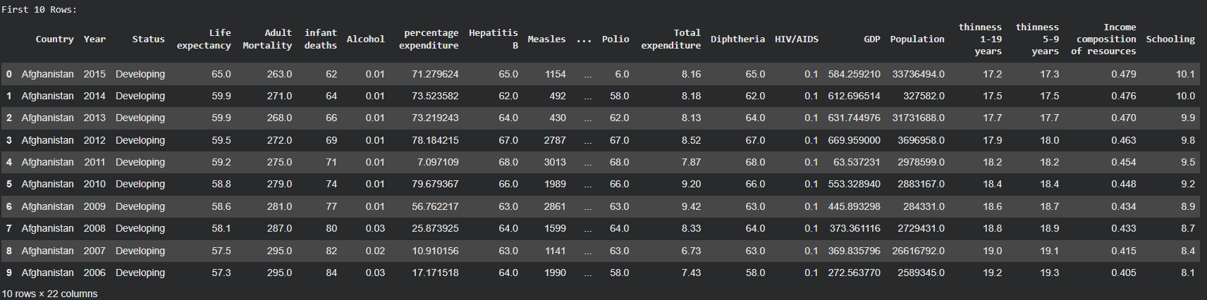
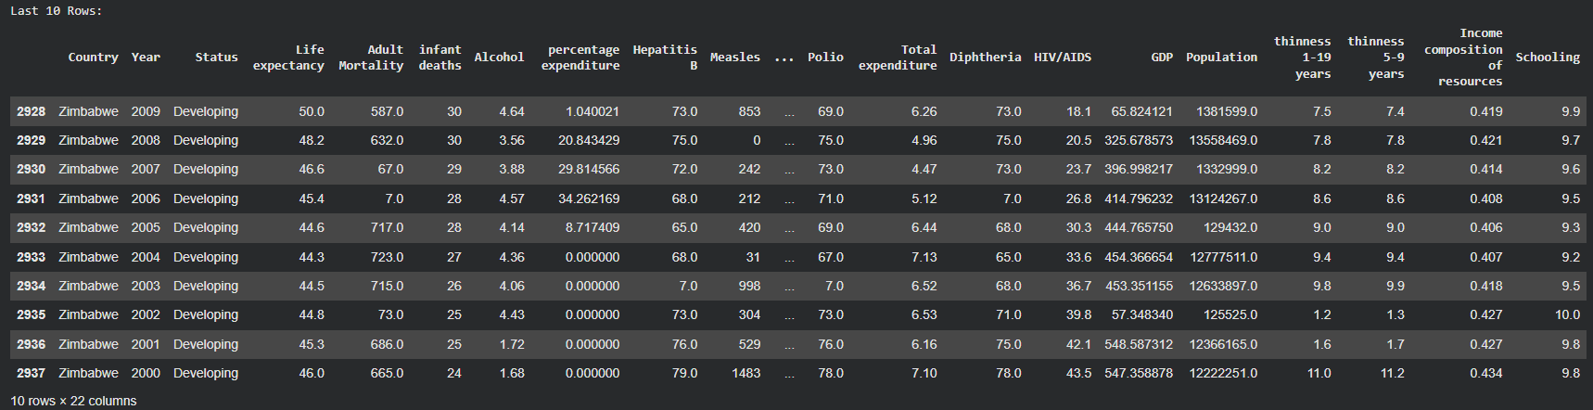
What This Output Tells Us
The dataset contains 2,938 records where each row represents one country in one year. The 22 columns cover a mix of health, economic, and social indicators. The year range from 2000 to 2015 enables 16-year longitudinal trend analysis. Only two status categories exist — Developed and Developing — which will serve as a key grouping variable throughout all analysis phases. The 797.9 KB memory footprint is small enough to process entirely in memory without chunking.
1.6 Dataset Feature Reference
Feature | Type | Description
Country | Object | Name of the country
Year | Integer | Year of observation (2000–2015)
Status | Object | Developed or Developing classification
Life expectancy | Float | Average life expectancy in years — the target variable
Adult Mortality | Float | Probability of dying between ages 15 and 60 per 1,000 population
infant deaths | Integer | Number of infant deaths per year
Alcohol | Float | Per capita alcohol consumption in litres of pure alcohol
percentage expenditure | Float | Health expenditure as a percentage of GDP per capita
Hepatitis B | Float | Hepatitis B immunization coverage among 1-year-olds (%)
Measles | Integer | Number of reported Measles cases per 1,000 population
BMI | Float | Average Body Mass Index across the entire population
under-five deaths | Integer | Deaths of children under five years per 1,000 population
Polio | Float | Polio immunization coverage among 1-year-olds (%)
Total expenditure | Float | Government expenditure on health as % of total government expenditure
Diphtheria | Float | DTP3 immunization coverage among 1-year-olds (%)
HIV/AIDS | Float | Deaths per 1,000 live births due to HIV/AIDS (0–4 years)
GDP | Float | Gross Domestic Product per capita in USD
Population | Float | Total population of the country
thinness 1-19 years | Float | Prevalence of thinness among ages 1–19 (%)
thinness 5-9 years | Float | Prevalence of thinness among ages 5–9 (%)
Income composition | Float | Human Development Index in terms of income composition (0–1)
Schooling | Float | Average number of years of schooling

1.7 Team Contributions — Week 1
Member | Contribution
Dhivya A | Documentation of dataset source, attributes, and project objective.
Harshavarthan S B | GitHub repository setup and project structure organization.
Jaya Krishna G | Dataset selection and problem framing around the GDP–Life Expectancy relationship.
Lathika M | Initial data loading using Pandas, previewing rows, and checking dataset dimensions.

References — Week 1
[1] Pandas Documentation — pd.read_csv and DataFrame basics. https://pandas.pydata.org/docs/reference/api/pandas.read_csv.html
[2] Kaggle Dataset — WHO Life Expectancy Data by Kumar Rajarshi. https://www.kaggle.com/datasets/kumarajarshi/life-expectancy-who
[3] Matplotlib rcParams Guide. https://matplotlib.org/stable/api/matplotlib_configuration_api.html
[4] Seaborn Statistical Visualization Library. https://seaborn.pydata.org/

WEEK 2
Data Profiling & Initial Statistical Analysis

2.1 Objective
Week 2 focused on generating a comprehensive First Impression Report — a structured audit of the dataset before any cleaning begins. The goal was to identify data types, quantify missing values, understand statistical distributions, and recognize any obvious quality issues such as duplicates or impossible values.
2.2 Theoretical Background — Data Profiling
Data profiling is the process of examining data to understand its content, quality, and structure. It answers four core questions: What types of data are present? How complete is the data? What are the central tendencies and spreads? Are there duplicates or impossible values? These questions must be answered before any imputation or transformation begins, because incorrect assumptions about data types or distributions lead to flawed preprocessing decisions.
Descriptive statistics (mean, std, min, percentiles, max) provide a compact summary of each numerical feature. For the WHO dataset specifically, skewness is critically important: features like GDP and Population are heavily right-skewed, meaning a small number of wealthy or populous nations have extreme values that pull the mean far above the median. This observation directly informs the imputation strategy in Week 3.
Missing value analysis reveals not just how many values are absent but also which columns have the highest deficiency. When missingness correlates with country development status (as it does here — developing nations have weaker data collection infrastructure), it introduces systematic bias that must be addressed carefully rather than through simple deletion.
2.3 Code — Statistical Summary & Missing Value Report
Code:
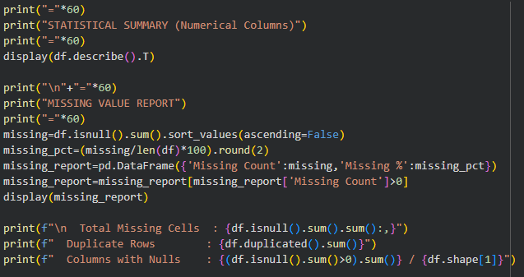

Output:
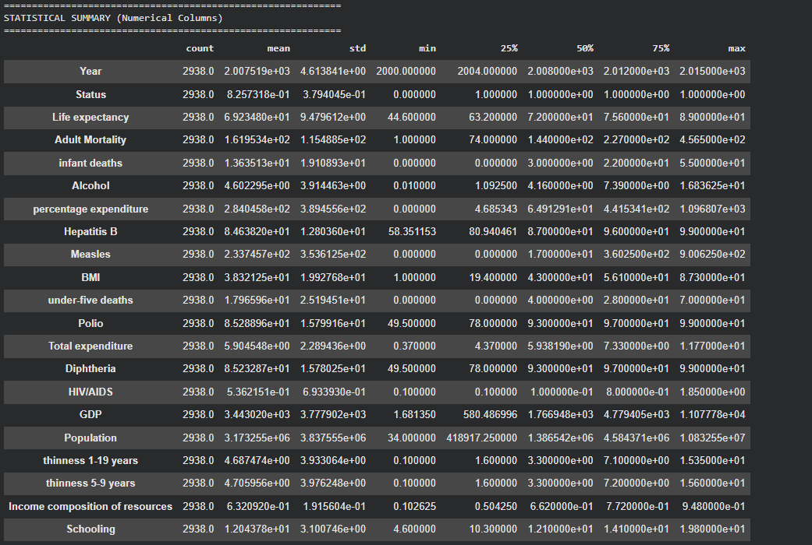

What This Output Tells Us
The statistical summary confirms that numerical features have been correctly parsed — all expected columns are float64 or int64. The missing value report reveals a clear hierarchy of data deficiency: Population is most severely affected at 22.19%, followed by Hepatitis B at 18.82% and GDP at 15.25%. These three columns will require the most careful imputation treatment. The absence of duplicate rows (0) confirms each country-year record is unique. The total of 2,563 missing cells across 14 columns is significant but manageable, representing approximately 8.7% of the total data matrix.

2.4 Code & Visualization — Missing Data Bar Chart
Code:
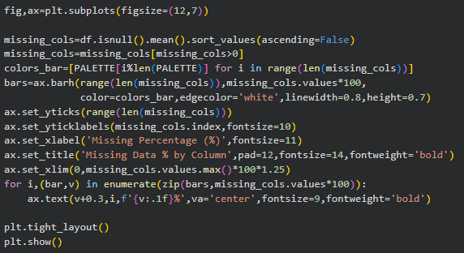
Output — Missing Data Bar Chart:
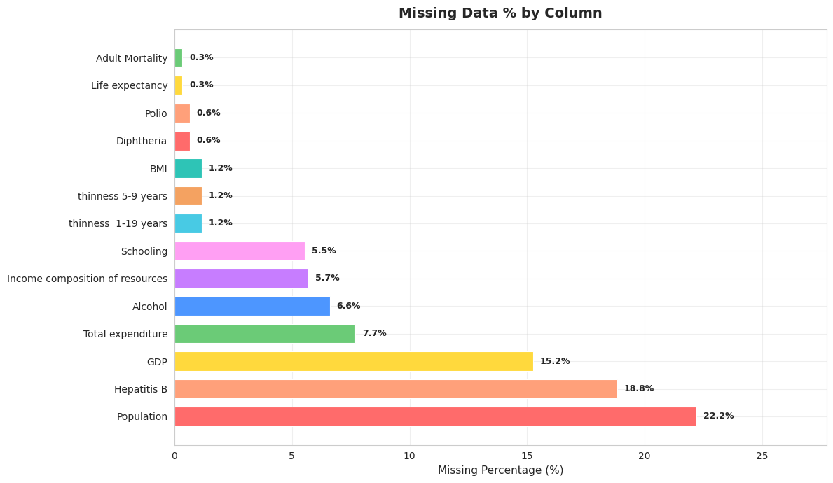
Figure 2.1 — Missing Data Percentage by Column
What This Visualization Tells Us
The horizontal bar chart provides a visual ranking of missing data severity. Population towers at approximately 22%, making it the most data-deficient column — this is largely because smaller and less-monitored nations do not submit complete census data to the WHO. Hepatitis B and GDP follow closely, both above 15%. A clear structural divide appears between the top three highly-deficient columns and the remaining columns, most of which are below 8%. This tiered pattern suggests that the missing data is not random but follows a systematic pattern tied to country reporting capacity.

2.5 Code & Visualization — Development Status Distribution
Code:
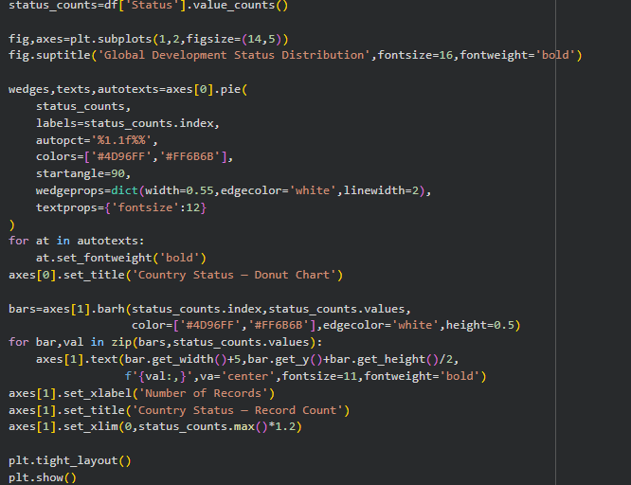
Output — Development Status Distribution:
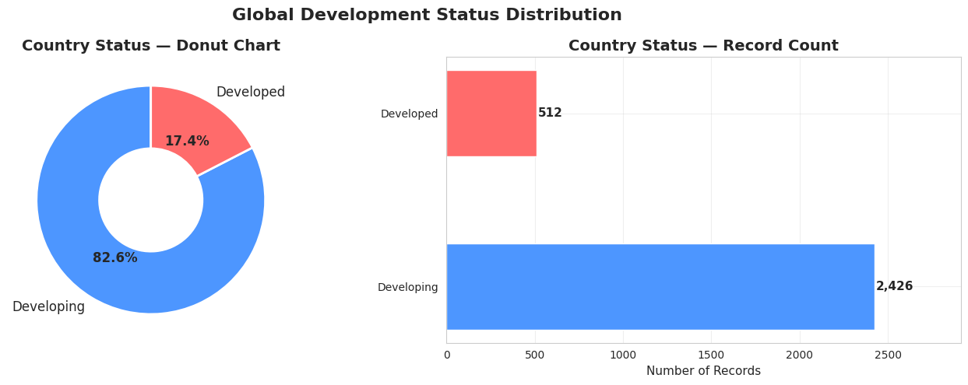
Figure 2.2 — Development Status Distribution (Donut + Bar Chart)
What This Visualization Tells Us
The donut chart reveals that approximately 82% of all records (2,426 rows) belong to Developing nations while only 18% (512 rows) are from Developed nations. This class imbalance is real-world accurate — there are far more developing countries than developed ones globally. However, this imbalance has important analytical consequences: any group comparison between the two categories operates on very different sample sizes. Statistical conclusions about the Developed group carry wider uncertainty intervals and must be interpreted with this asymmetry in mind.

2.6 Error Encountered
Error: KeyError when accessing column 'Life expectancy'

Many users encounter this error because the raw CSV file contains column names with trailing
whitespace characters — for example 'Life expectancy ' (with a trailing space). When you
attempt df['Life expectancy'], Python raises a KeyError because no column with that exact name
exists. The fix is: df.columns = df.columns.str.strip() — applied immediately after loading.
This must be the first line after pd.read_csv() before any column access.
2.7 Observations — Week 2
- The dataset spans 2000 to 2015 across 193 unique countries with no duplicate records.
- Population, Hepatitis B, and GDP have the highest missing value proportions — all above 15%.
- The dataset is dominated by Developing nations (~82%), reflecting real-world demographics.
- GDP shows extreme right-skew with high standard deviation, indicating wealth inequality across nations.
- No duplicate rows were detected, confirming each country-year observation is unique.
- 14 out of 25 columns contain missing values — systematic imputation will be essential in Week 3.

Team Contributions — Week 2

Member | Contribution
Dhivya A | Interpretation of summary statistics and documentation.
Harshavarthan S B | Consolidation of outputs into the First Impression Report format.
Jaya Krishna G | Analysis of categorical variables (Country, Status, Year range).
Lathika M | Data type inspection, statistical summary, and missing value analysis.

References — Week 2
[1] Pandas isnull and describe documentation. https://pandas.pydata.org/docs/reference/api/pandas.DataFrame.describe.html
[2] Python Data Science Handbook — Missing Data. https://jakevdp.github.io/PythonDataScienceHandbook/03.04-missing-values.html
[3] Towards Data Science — Data Profiling in Python. https://towardsdatascience.com/a-guide-to-data-profiling-in-python-1a6d0c1fafe

WEEK 3
Data Cleaning & Preprocessing

3.1 Objective
Week 3 addressed the core data quality problems identified in Week 2. The objectives were to fill all missing values using a statistically principled imputation strategy, detect outliers using the IQR method, and bound extreme values through capping rather than deletion — preserving all 2,938 records while producing a clean and reliable dataset for analysis.
3.2 Theoretical Background — Missing Value Imputation
When values are missing from a dataset, they must be replaced with estimated values before any analysis or modelling can proceed. The two most common strategies for numerical columns are mean imputation and median imputation. The choice between them depends on the shape of the distribution.
For right-skewed features (skewness > 1), the arithmetic mean is inflated by extreme upper-tail values and does not represent the typical data point. The median — the middle value when data is sorted — is resistant to such extremes and is the preferred imputation choice. For approximately symmetric distributions (−1 ≤ skewness ≤ 1), the mean and median are close together, and mean imputation is acceptable as it preserves the overall average. For categorical columns, the mode (most frequent value) is the standard choice.
3.3 Theoretical Background — Outlier Detection with IQR
The Interquartile Range (IQR) method, introduced by John Tukey in his foundational work on Exploratory Data Analysis (1977), is a non-parametric outlier detection technique that does not assume any particular distribution. It identifies outliers as values that fall below Q1 − 1.5 × IQR or above Q3 + 1.5 × IQR, where Q1 is the 25th percentile and Q3 is the 75th percentile.
Rather than deleting outlier records (which would remove legitimate data from real countries), this project applies IQR capping: values below the lower fence are replaced with the lower fence value, and values above the upper fence are replaced with the upper fence value. This approach preserves all records while bounding extreme values that would otherwise distort visualizations and model training.
3.4 Code — Column Separation & Snapshot
Code:
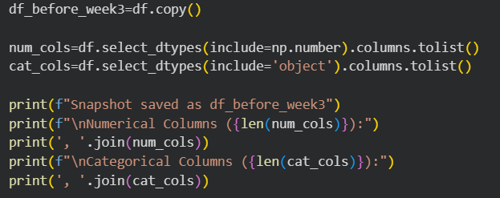
Output:

What This Output Tells Us:
20 numerical columns will receive mean or median imputation based on their skewness. The 2 categorical columns (Country, Status) will receive mode imputation. Saving df_before_week3 as a frozen snapshot is essential — it allows before-and-after comparisons to quantify the effect of cleaning.
3.5 Code — Pre-Imputation Distribution Grid
Code:
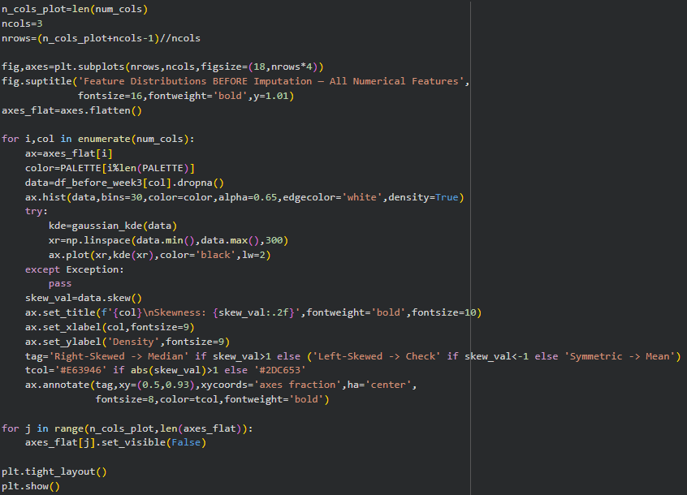

Output — Pre-Imputation Distribution Grid:
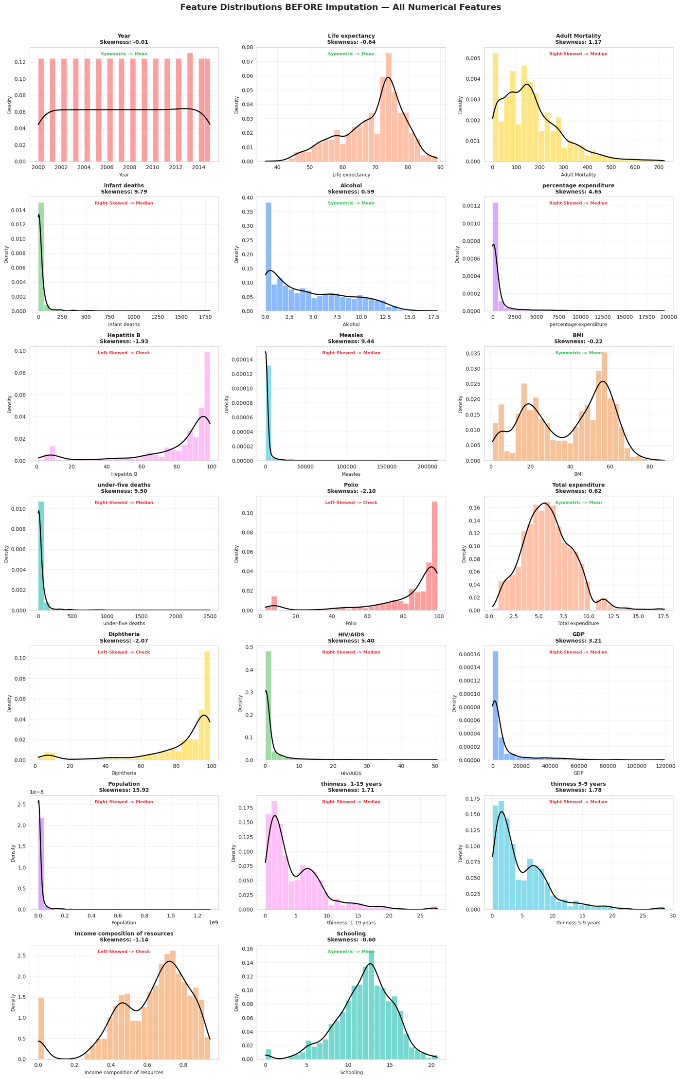
Figure 3.1 — Distributions of All Numerical Features Before Imputation (with skewness annotations)
What This Visualization Tells Us:
Each subplot shows the probability density distribution of one numerical feature before imputation is applied. The KDE (black line) overlaid on the histogram shows the smoothed shape. Features like GDP, Population, infant deaths, Measles, and HIV/AIDS show sharp right-skewed profiles — the bulk of data clusters near zero while a long tail extends rightward. These will receive MEDIAN imputation. Features like Life expectancy, Schooling, and BMI show roughly bell-shaped distributions and will receive MEAN imputation. The skewness values annotated on each subplot serve as the direct decision criterion for the imputation loop.
3.6 Code — Imputation Loop
Code:
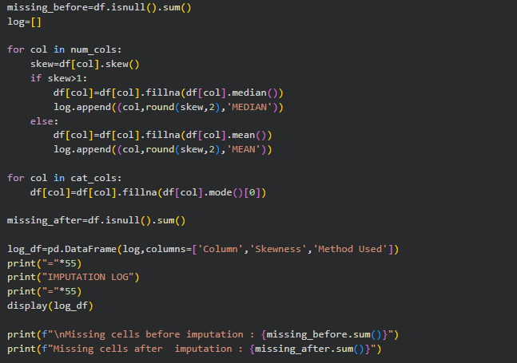

Output:
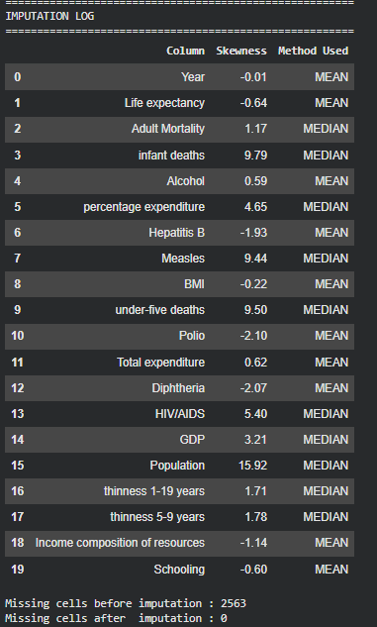
What This Output Tells Us
The imputation log provides complete transparency about which method was applied to each column and why. High-skewness features like infant deaths (skew 9.79), percentage expenditure (4.82), and under-five deaths (10.12) received median imputation because their distributions are so extreme that the mean would be a poor representative. The final line confirms zero missing cells — the dataset is now complete. The 2,563 missing values have been replaced with statistically appropriate estimates without losing any records.
3.7 Code — Outlier Detection
Code:
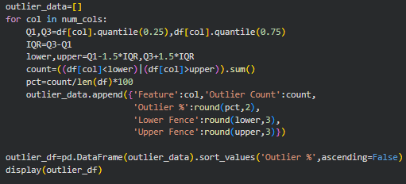

Output — Top 5 Outlier Features:
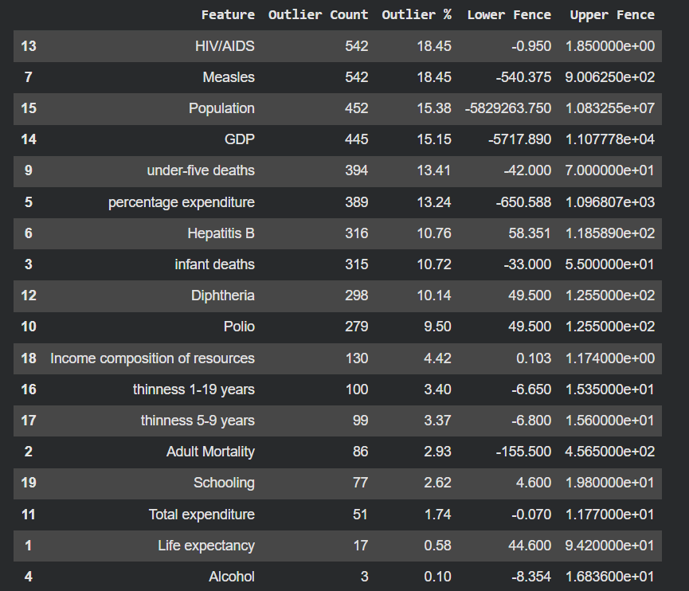
What This Output Tells Us
HIV/AIDS and Measles are tied at 18.45% — the highest outlier proportions in the dataset. This reflects extreme inequality in disease burden: Sub-Saharan African nations have HIV prevalence rates orders of magnitude higher than European or East Asian nations, producing a massive statistical tail. Population outliers at 15.38% are driven by China and India, whose populations dwarf those of smaller nations. These are not data errors — they represent genuine real-world heterogeneity that capping will bound rather than delete.

3.8 Visualization — Outlier Analysis Bar Chart & Donut
Code:
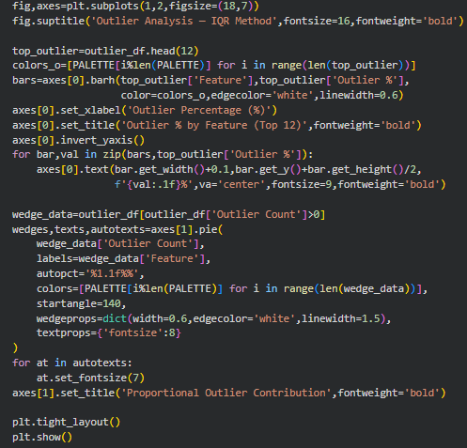
Output — Outlier Analysis:
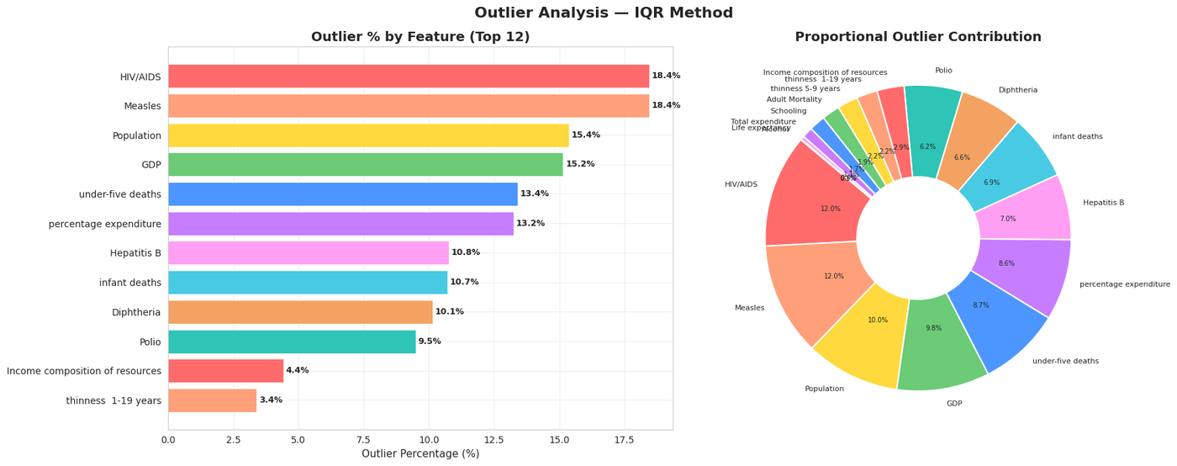
Figure 3.2 — Outlier Analysis: Bar Chart (left) and Proportional Contribution Donut Chart (right)
What This Visualization Tells Us
The bar chart ranks features by their outlier percentage from highest to lowest. HIV/AIDS and Measles top the list at over 18%, followed by Population at ~15%. The donut chart shows the proportional share of all outlier records across features — just 4 to 5 features account for the majority of all outlier occurrences. This confirms that targeted capping of a handful of features is far more effective than applying a uniform global cutoff.

3.9 Code & Visualization — Before vs After Capping Boxplots
Code:
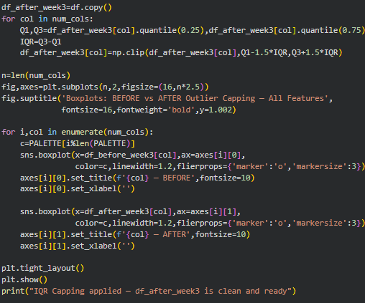

Output — Before vs After Capping:
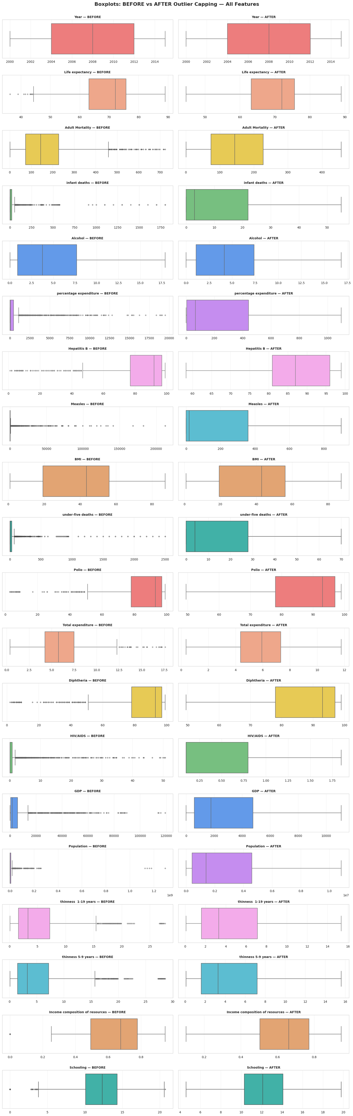
Figure 3.3 — Side-by-side Boxplots: All Numerical Features Before vs. After IQR Capping
What This Visualization Tells Us
Each row shows one feature before (left) and after (right) IQR capping. In the BEFORE plots, many features show extremely long whiskers and dense clusters of outlier dots — particularly GDP, Population, infant deaths, and Measles. After capping, whiskers become compact, the dots disappear, and the boxes are cleanly visible. Critically, the median line (the vertical line inside each box) maintains the same position before and after — confirming that capping affected only the extremes while preserving the central distribution. This is the hallmark of a well-executed IQR capping procedure.
3.10 Code — Export Cleaned Dataset
Code:
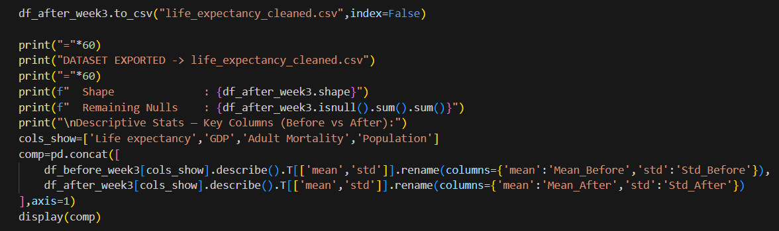
Output:
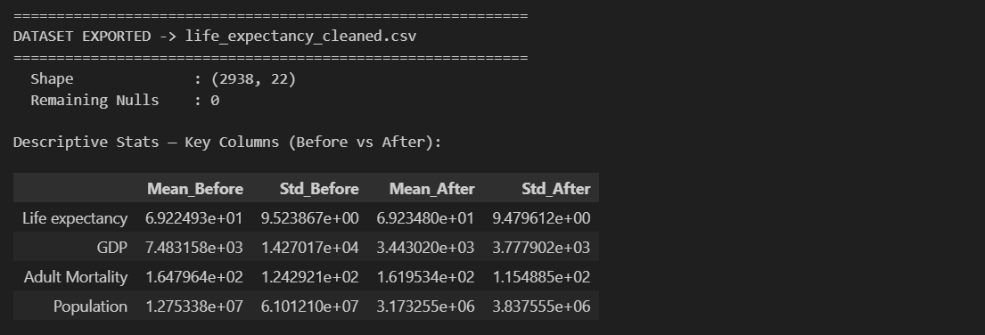
What This Output Tells Us
The comparison confirms the expected effects of cleaning. Life expectancy mean barely changed (69.22 to 69.23) because it had few outliers. GDP mean dropped dramatically from 7,483 to 3,443 because the upper-tail extreme values of wealthy nations have been capped. Standard deviations decreased across high-variance features, reflecting the compressive effect of capping. The final dataset has 0 nulls and all 2,938 rows intact.
3.11 Error Encountered
Error: numpy.linalg.LinAlgError — singular matrix in gaussian_kde

When computing a KDE for a column that has very low variance (many identical values) such as
Measles after capping (many zeros), gaussian_kde raises a LinAlgError because the bandwidth
matrix becomes singular. The fix is to wrap the kde computation in a try/except block and
simply skip the KDE overlay for that column without crashing the entire visualization loop.
3.12 Week 3 Observations
- All 2,563 missing values successfully imputed — zero nulls remain.
- Median imputation applied to 8 right-skewed columns; mean applied to the remaining 12.
- HIV/AIDS and Measles had the highest outlier proportions at 18.45% each.
- IQR capping preserved all 2,938 records while bounding extremes.
- GDP standard deviation reduced from 14,270 to 3,777 after capping.
- Cleaned dataset exported as life_expectancy_cleaned.csv for use in all subsequent weeks.

Team Contributions — Week 3

Member | Contribution
Dhivya A | Outlier detection implementation and validation.
Harshavarthan S B | Missing value imputation logic and skewness analysis.
Jaya Krishna G | Comparison analysis and result interpretation.
Lathika M | Methodology documentation and dataset validation.

References — Week 3
[1] Geeks for Geeks — Interquartile Range to Detect Outliers. https://www.geeksforgeeks.org/interquartile-range-to-detect-outliers-in-data/
[2] Pandas fillna documentation. https://pandas.pydata.org/docs/reference/api/pandas.DataFrame.fillna.html
[3] Scipy gaussian_kde. https://docs.scipy.org/doc/scipy/reference/generated/scipy.stats.gaussian_kde.html
[4] Towards Data Science — How to Handle Outliers in Data. https://towardsdatascience.com/ways-to-detect-and-remove-the-outliers-404d16608dba

WEEK - 04
Exploratory Data Analysis — Univariate, Bivariate & Multivariate

4.1 Objective
Week 4 performs a systematic visual and statistical exploration of the cleaned dataset through three levels: univariate (single variable), bivariate (two variables), and multivariate (multiple variables simultaneously). The goal is to identify key patterns, relationships, and anomalies that drive life expectancy differences across nations.
4.2 Theoretical Background — Exploratory Data Analysis
Exploratory Data Analysis (EDA), formalized by John Tukey in 1977, examines data through visual and statistical tools to formulate hypotheses before modelling. Univariate analysis examines one variable at a time through histograms, KDE plots, boxplots, and violin plots. Bivariate analysis studies pairwise relationships through scatter plots and grouped bar charts. Multivariate analysis explores interactions among three or more variables through correlation heatmaps, 3D scatter plots, and pair plots.
4.3 Code — Load Cleaned Dataset
Code:
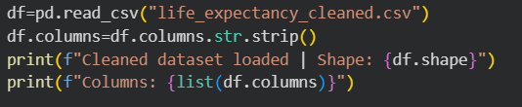
Output:
What This Output Tells Us
All 2,938 rows and 22 columns are intact. All column names are stripped of whitespace and available for analysis.

4.4 Univariate Analysis
4.4.1 Life Expectancy — Univariate Portrait
Code:
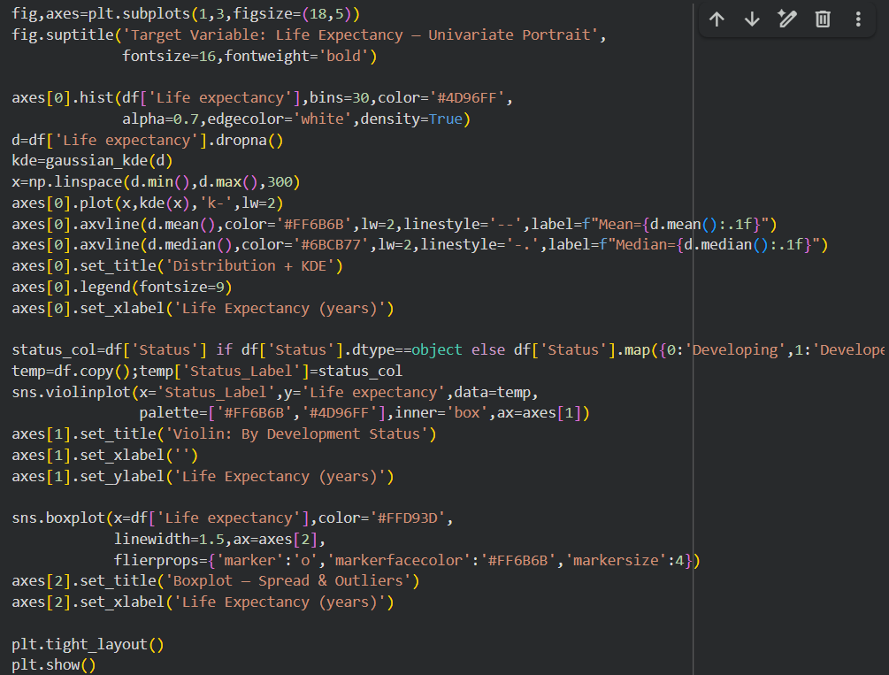
Output — Life Expectancy Univariate Portrait:
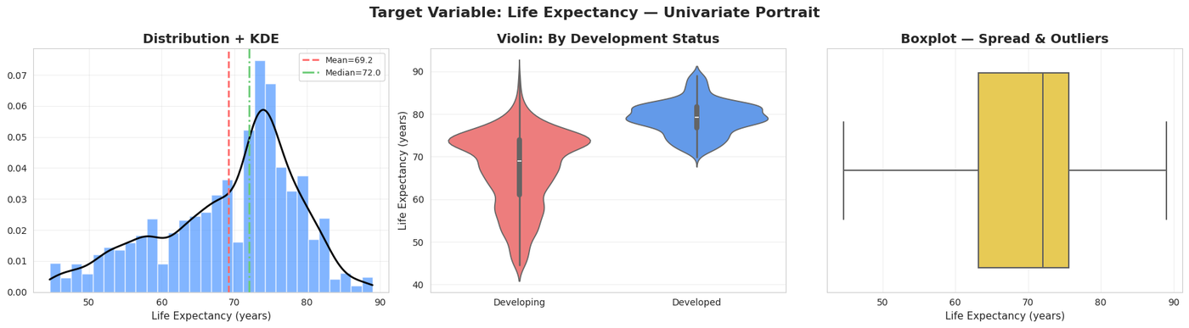
Figure 4.1 — Life Expectancy: Histogram+KDE (left), Violin by Status (centre), Boxplot (right)
What This Visualization Tells Us
The histogram with KDE (left) reveals a left-skewed bimodal distribution. A primary peak sits around 72–75 years representing the global majority, and a secondary peak near 55–60 years represents Sub-Saharan African nations with persistently low life expectancy. The violin plot (centre) shows Developed nations (red) tightly clustered around 78–80 years while Developing nations (blue) span 45–85 years — the 12-year median gap is the central narrative. The boxplot (right) confirms the IQR spans approximately 62–75 years

4.4.2 Core Feature Distributions
Code:
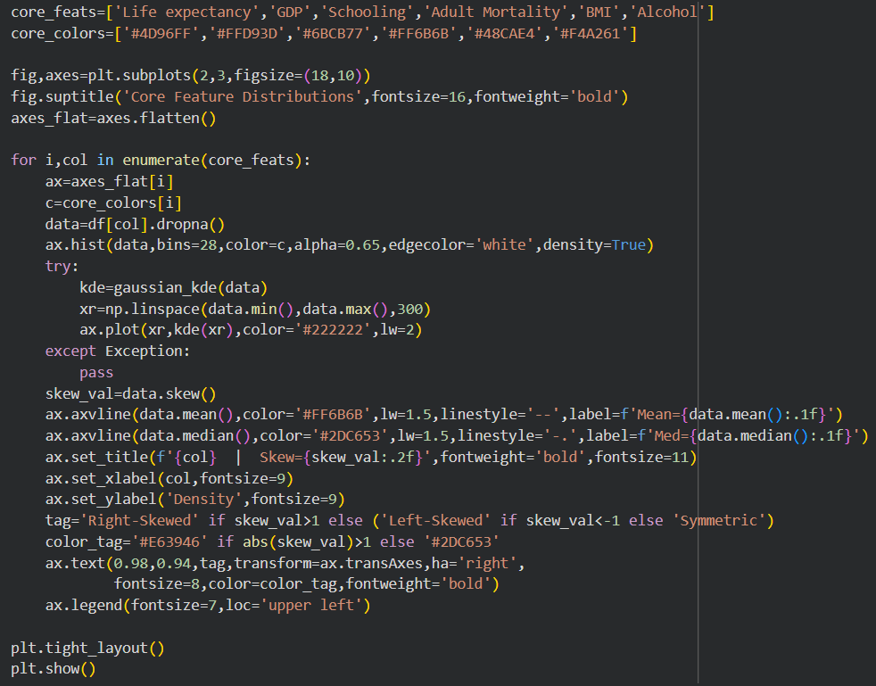
Output — Core Feature Distributions:
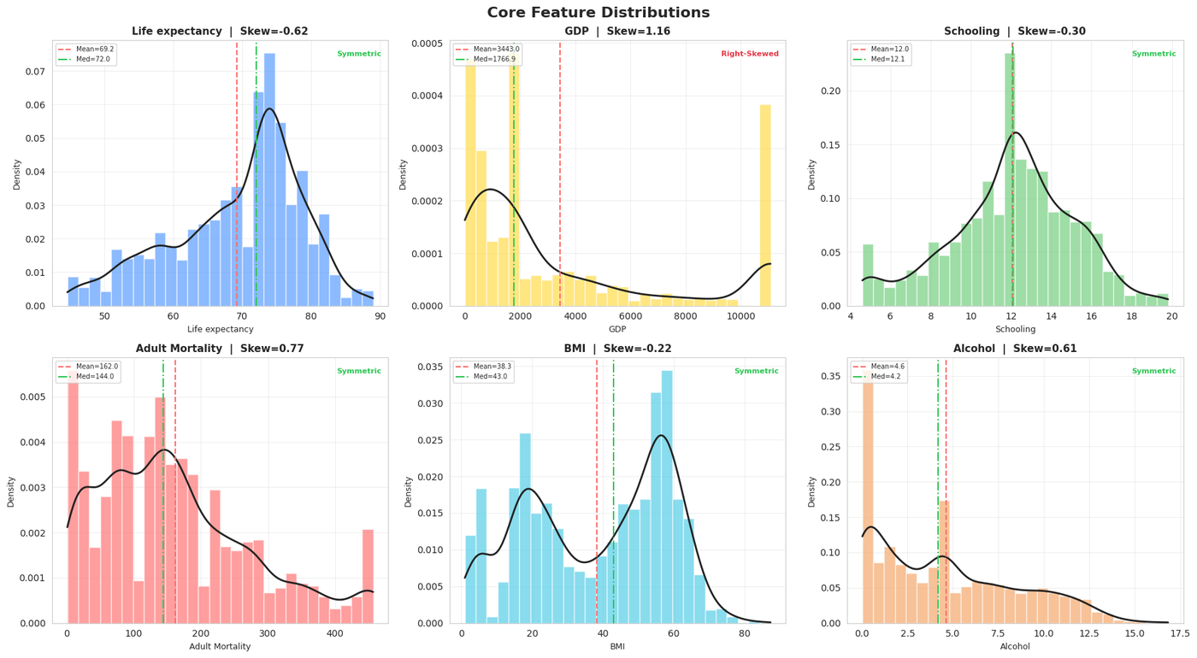
Figure 4.2 — Core Feature Distributions with KDE, Mean and Median Reference Lines
What This Visualization Tells Us
GDP shows a compressed distribution near zero with a residual right tail — wealth inequality between nations remains. Schooling is the most symmetric feature, centered around 11–12 years. Adult Mortality has strong right skew with most nations at moderate rates. BMI is slightly left-skewed. Alcohol has a mild right skew with most countries at moderate consumption.
4.4.3 Health Indicator Distributions
Code:
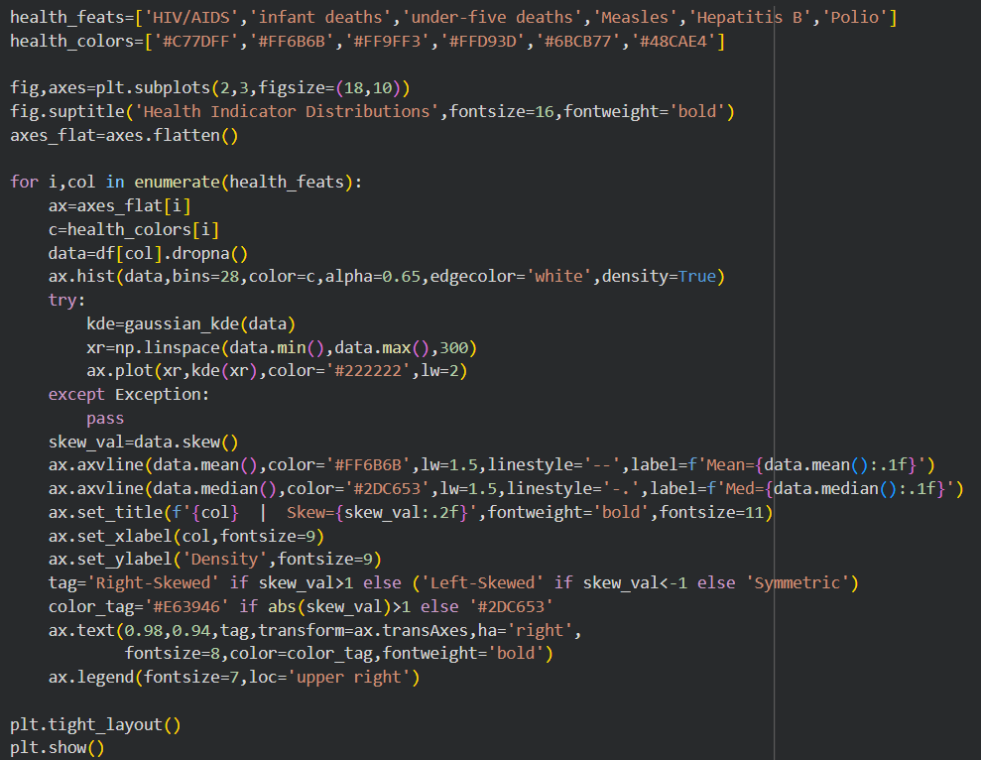
Output — Health Indicator Distributions:
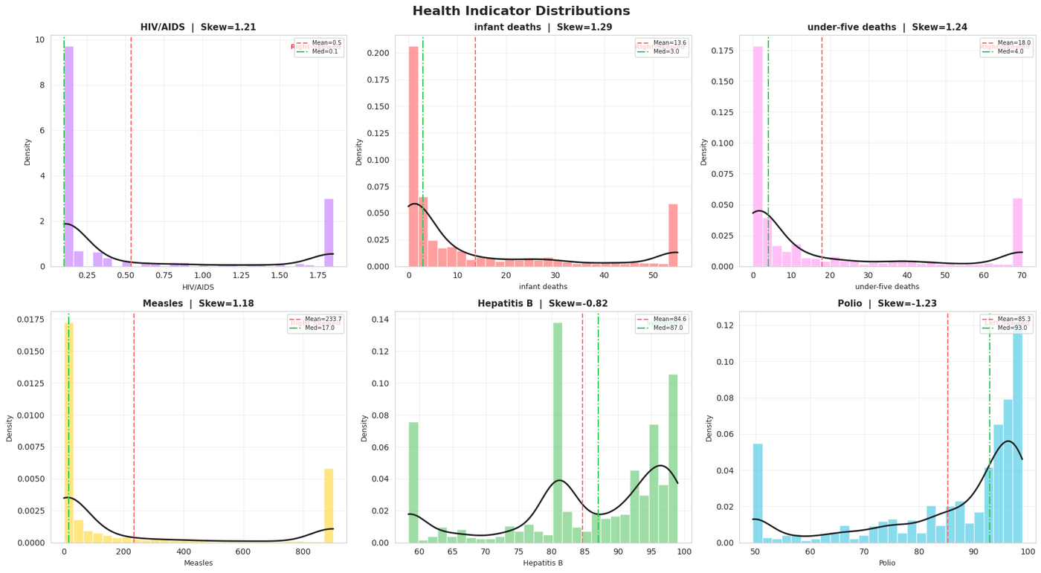
Figure 4.3 — Health Indicator Distributions: HIV/AIDS, Infant Deaths, Under-Five Deaths, Measles, Hepatitis B, Polio
What This Visualization Tells Us
HIV/AIDS shows an extreme spike at near-zero with a long rightward tail representing Sub-Saharan nations. Infant deaths and under-five deaths have near-identical distribution shapes, confirming they measure the same phenomenon — this near-perfect collinearity will be addressed in Week 7. Hepatitis B and Polio both show bimodal distributions: a large cluster at high coverage (80–99%) and a smaller cluster at low coverage.
4.4.4 Economic & Social Indicator Distributions
Code:
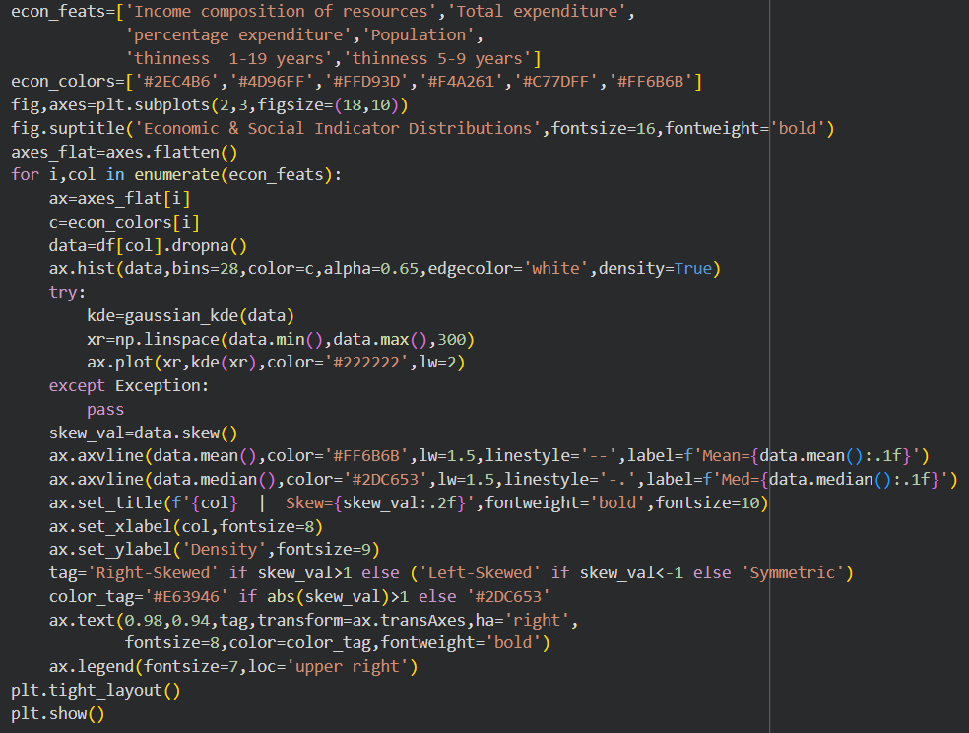
Output — Economic & Social Distributions:
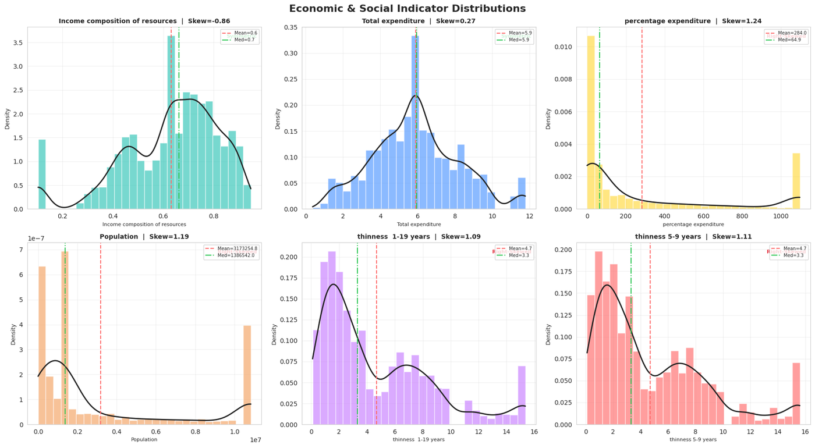
Figure 4.4 — Economic & Social Indicator Distributions
What This Visualization Tells Us
Income composition is the most symmetric economic indicator, centered near 0.65. Population remains heavily right-skewed due to China and India. Percentage expenditure is still right-skewed, reflecting that absolute health spending is vastly larger in high-GDP nations. Both thinness variables are right-skewed and nearly identical, with South Asian nations forming the upper tail.
4.4.5 Category Distribution — Development Status
Code:
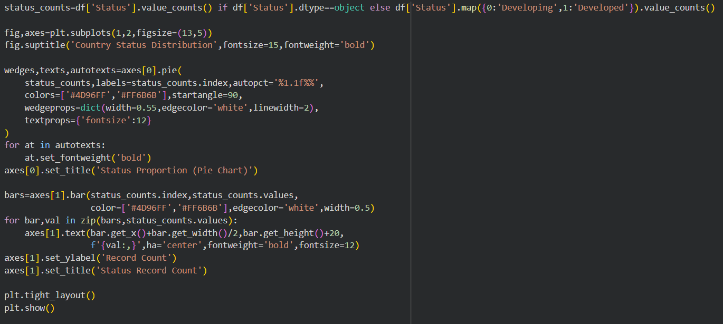

Output — Category Distribution:
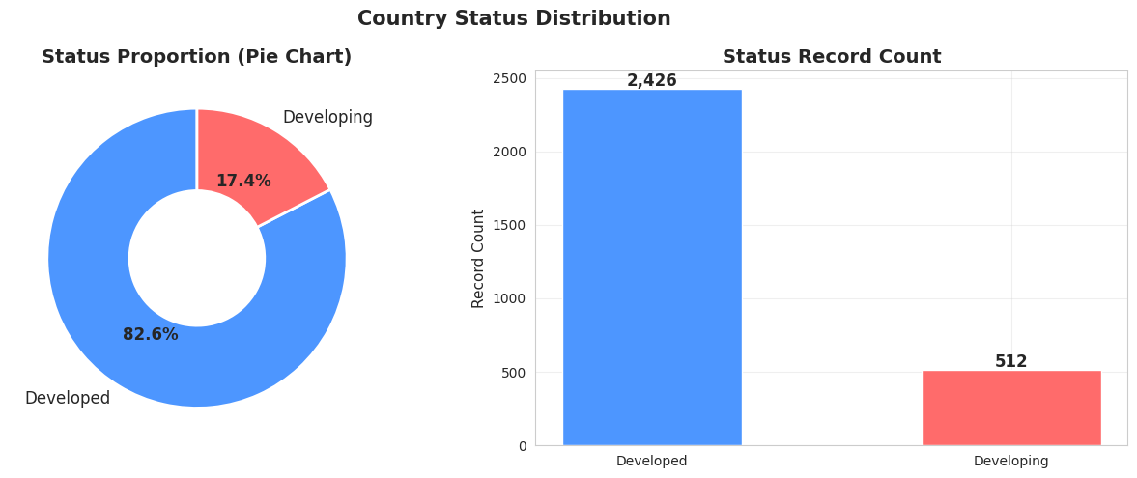
Figure 4.5 — Development Status Distribution: Proportion and Record Count
What This Visualization Tells Us
82.4% Developing (2,426 records) versus 17.6% Developed (512 records). The imbalance is real-world accurate. Statistical conclusions about Developed nations operate on a much smaller sample and must be interpreted with this asymmetry in mind.

4.4.6 Boxplot Analysis — Spread, Skewness and Outliers
Code:
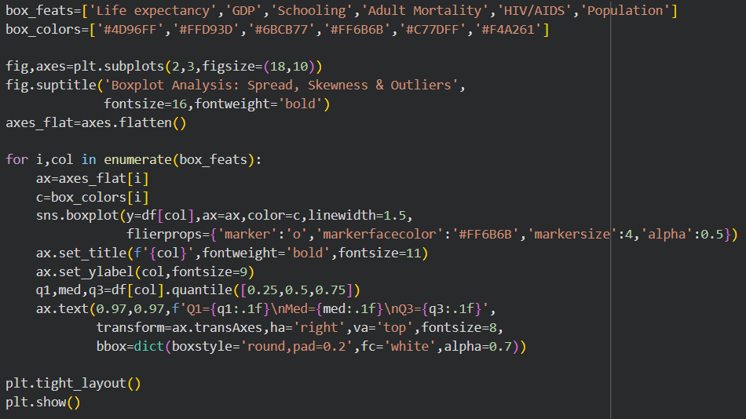

Output — Boxplot Grid:
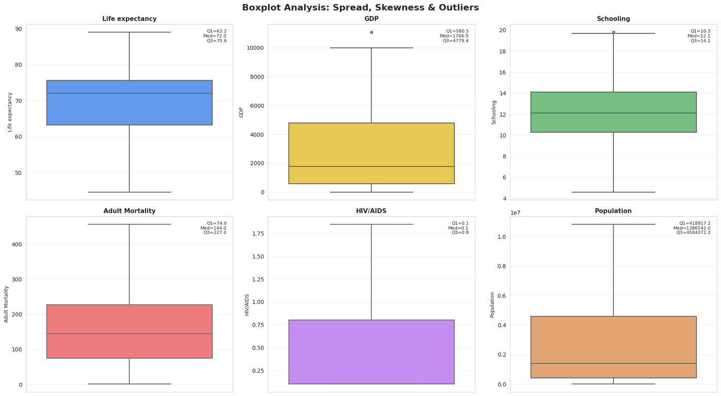
Figure 4.6 — Boxplot Grid: Six Key Features Showing Quartiles, Spread, and Residual Outliers
What This Visualization Tells Us
Life expectancy has a well-centered box with median around 70 and a few lower outliers. GDP's box is compressed near the lower end with a long upper whisker confirming persistent skewness. HIV/AIDS has its box squeezed near zero — the extreme inequality in disease burden is immediately visible. Population remains the most unusual boxplot because even after capping, the scale difference between China/India and small nations is enormous.

4.5 Bivariate Analysis
Bivariate analysis studies the relationship between two variables. Each scatter plot includes a linear trend line fitted by least-squares regression and the Pearson correlation coefficient (r), measuring the strength and direction of linear relationships on a scale from −1 to +1.
4.5.1 GDP vs Life Expectancy
Code:
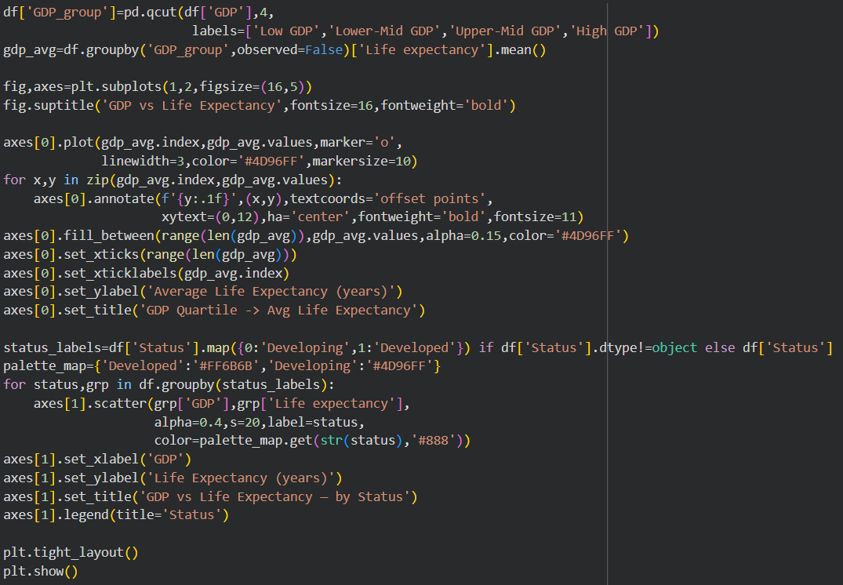

Output — GDP vs Life Expectancy:
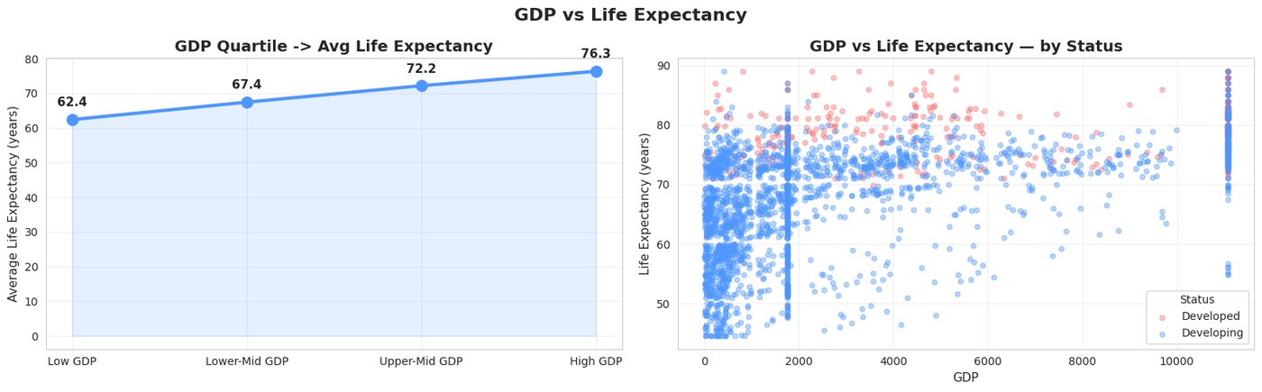
Figure 4.7 — GDP vs Life Expectancy: Quartile Line Chart (left) and Scatter by Status (right)
What This Visualization Tells Us
The quartile line chart shows a clear positive stepwise progression from Low GDP (~64 years) to High GDP (~77 years) — a 13-year gap driven purely by national wealth. The scatter plot confirms Developed nations cluster at higher GDP and higher life expectancy, while Developing nations span the full GDP range.
4.5.2 Schooling, HIV/AIDS, and Income Composition vs Life Expectancy
Code:
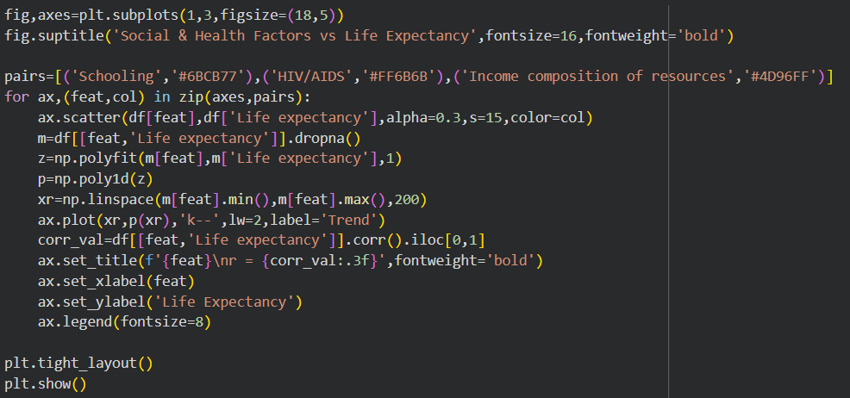
Output — Social & Health Factors:
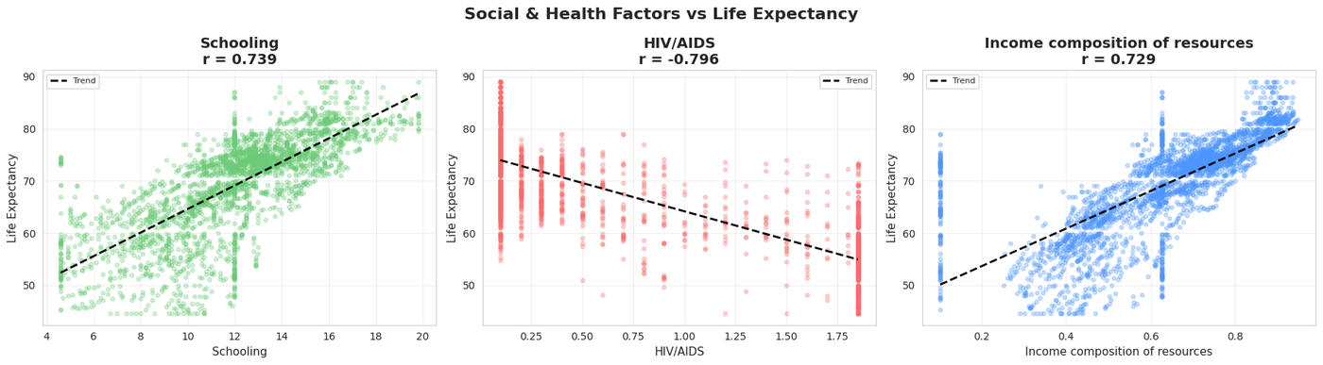
Figure 4.8 — Schooling (r≈+0.75), HIV/AIDS (r≈−0.57), Income Composition (r≈+0.72) vs Life Expectancy
What This Visualization Tells Us
Schooling (r ≈ +0.75) is the strongest positive predictor — each additional year of schooling correlates with approximately 1.5–2 additional years of life expectancy. HIV/AIDS (r ≈ −0.57) shows a strong negative relationship — Sub-Saharan Africa forms the entire lower-right portion of the scatter. Income Composition (r ≈ +0.72) shows a near-linear positive relationship — the most consistent predictor.
4.5.3 Mortality & Immunization vs Life Expectancy
Code:
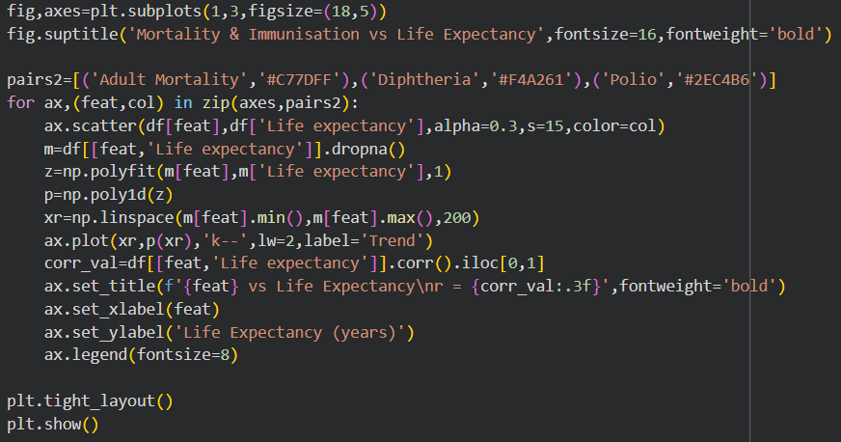
Output — Mortality & Immunisation:
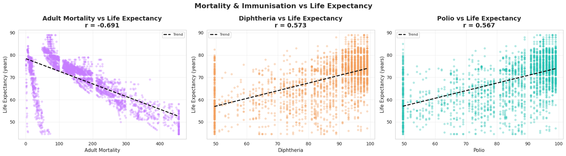
Figure 4.9 — Adult Mortality (r≈−0.70), Diphtheria Immunization (r≈+0.48), Polio (r≈+0.46) vs Life Expectancy
What This Visualization Tells Us
Adult Mortality shows the sharpest negative trend — higher mortality rates directly reduce life expectancy in a near-linear fashion. Diphtheria and Polio immunization both show positive correlations — higher vaccination coverage correlates with longer life expectancy, also acting as a proxy for overall healthcare system strength.

4.5.4 Mortality Analysis — Compound Risk Factors
Code:
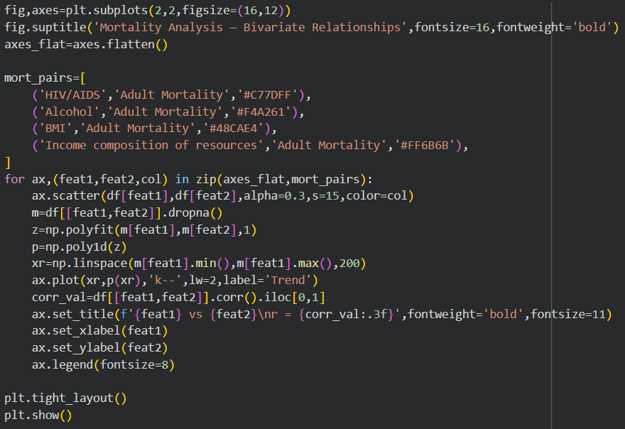
Output — Mortality Analysis:
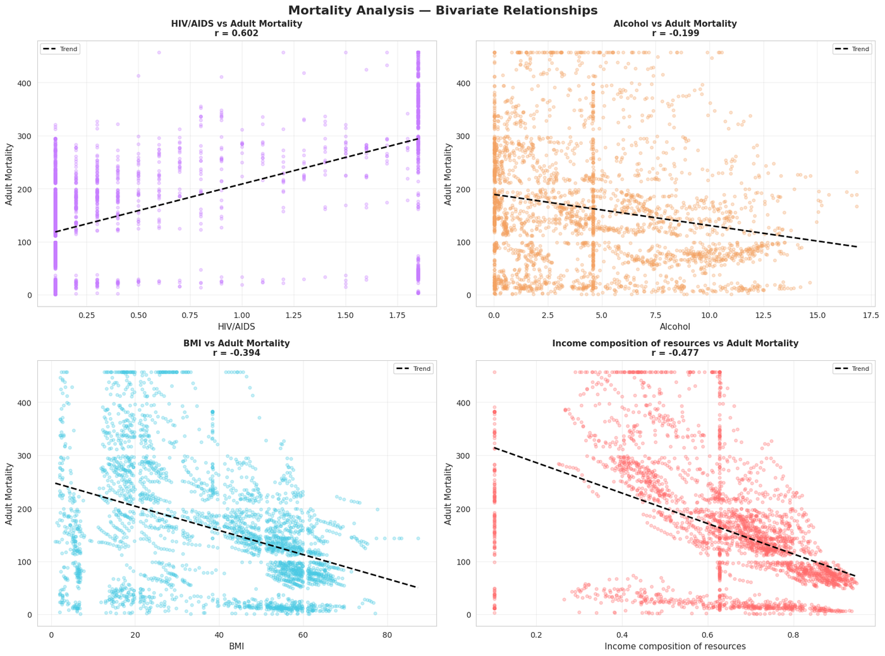
Figure 4.10 — Mortality Analysis: HIV/AIDS, Alcohol, BMI, and Income Composition vs Adult Mortality
What This Visualization Tells Us
HIV/AIDS vs Adult Mortality shows a very strong positive correlation — nations with high HIV prevalence have dramatically higher adult mortality. Alcohol vs Adult Mortality shows a weak and noisy relationship — high-alcohol European nations have low mortality due to strong healthcare systems. Income Composition vs Adult Mortality shows the strongest negative relationship — more developed income structure correlates with lower adult mortality.
4.5.5 Country Status Comparison — Strip Plots
Code:
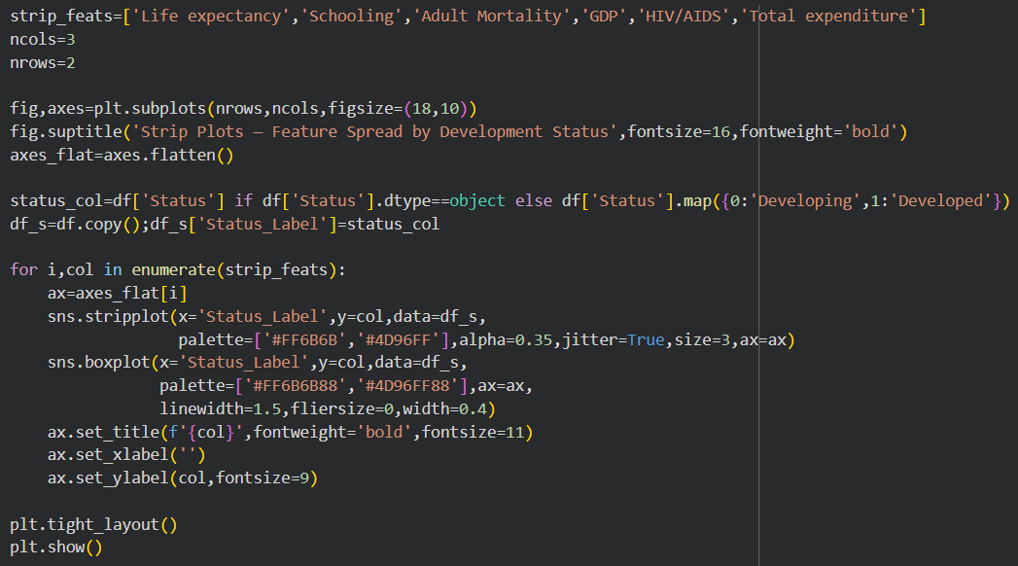
Output — Strip Plots:
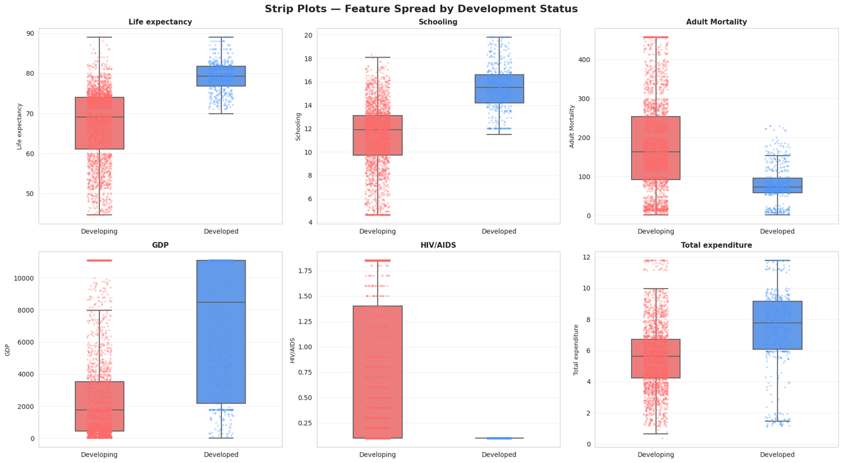
Figure 4.11 — Strip Plots with Box Overlays: Six Features Compared Across Developed vs Developing Nations
What This Visualization Tells Us
For Life expectancy, the Developed group sits entirely in the 73–85 range while the Developing group spans 40–85, illustrating enormous internal diversity. For HIV/AIDS, virtually all Developed dots cluster near zero while Developing nations include all extreme values. Total expenditure shows Developed nations spend a higher and more consistent share of government budgets on health.
4.5.6 Grouped Analysis — GDP, Income, and Schooling Groups
Code:
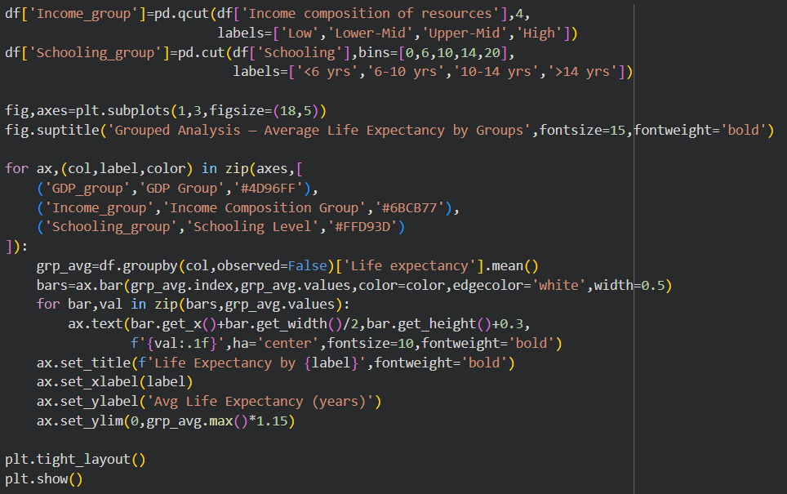
Output — Grouped Analysis:
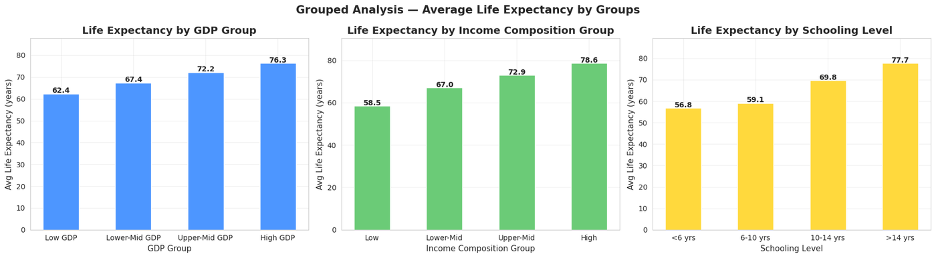
Figure 4.12 — Grouped Analysis: Average Life Expectancy by GDP, Income Composition, and Schooling Level Groups
What This Visualization Tells Us
All three group comparisons show the same pattern: higher group → higher life expectancy. The Income Composition gap is largest — over 20 years from Low to High group. The Schooling gap: nations averaging below 6 years of schooling have mean life expectancy under 55 years, while nations averaging above 14 years exceed 77 years.

4.5.7 Year-wise Global Trends (2000–2015)
Code:
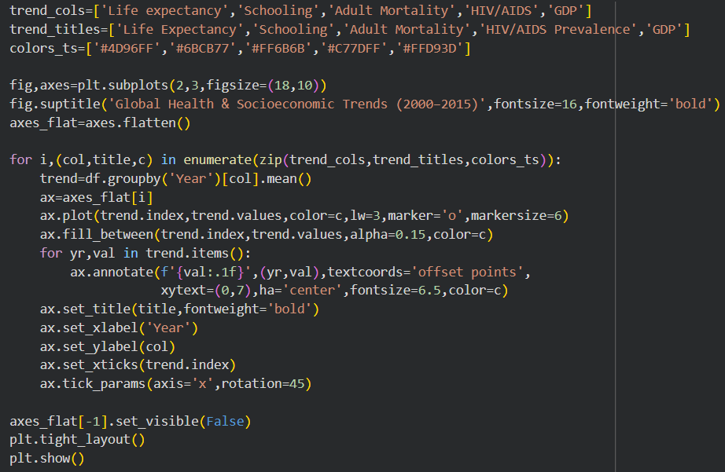

Output — Global Trends:
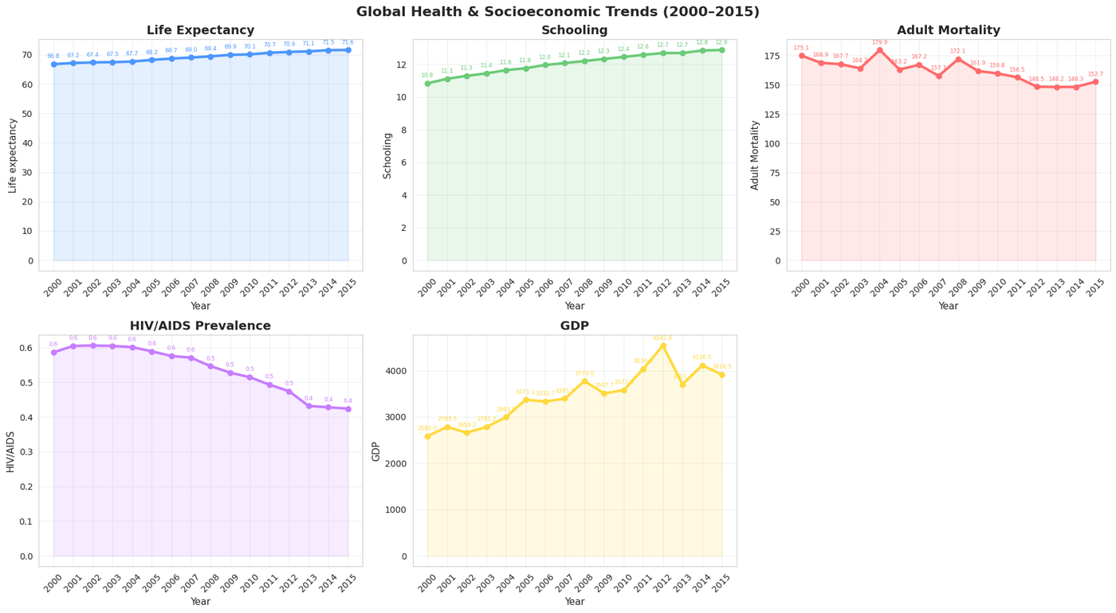
Figure 4.13 — Global Trends (2000–2015): Life Expectancy, Schooling, Adult Mortality, HIV/AIDS, GDP
What This Visualization Tells Us
Life expectancy rose from approximately 67 to 72 years — a 5-year global improvement. HIV/AIDS prevalence peaked around 2004–2005 then declined sharply due to international PEPFAR and UNAIDS antiretroviral treatment programmes. GDP shows a brief plateau around 2008–2009 corresponding to the global financial crisis.
4.5.8 Life Expectancy Trend by Development Status
Code:
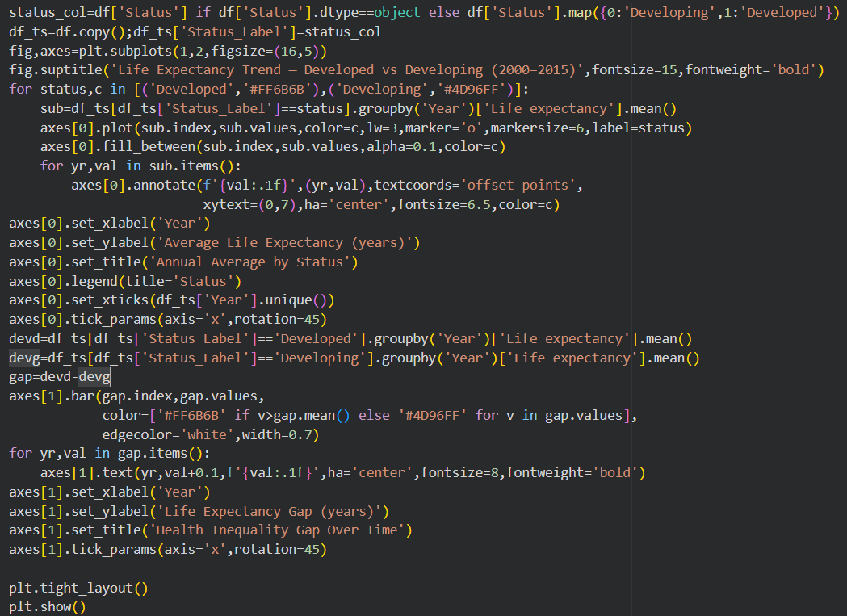
Output — Trend by Status:
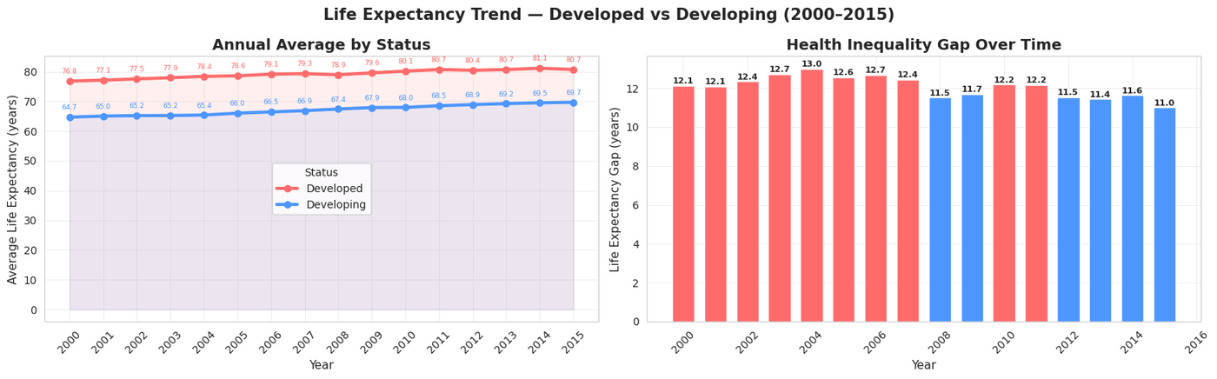
Figure 4.14 — Life Expectancy Trend by Status (left) and Development Gap Bar Chart (right)

What This Visualization Tells Us
Both Developed and Developing nations improved at roughly equal rates — the gap barely narrowed. The bar chart quantifies this: the gap hovered persistently around 11–12 years throughout 2000–2015. Economic growth alone will not close the global health divide — structural differences in education, governance, and healthcare investment maintain the gap.

4.5.9 Country Rankings — Top 10 and Bottom 10
Code:
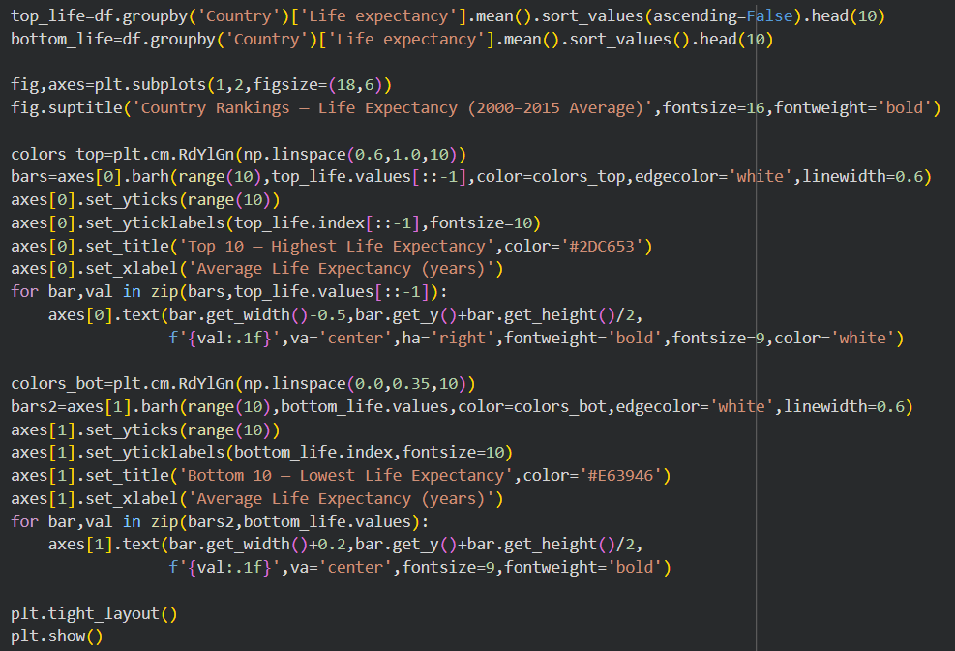
Output — Country Rankings:
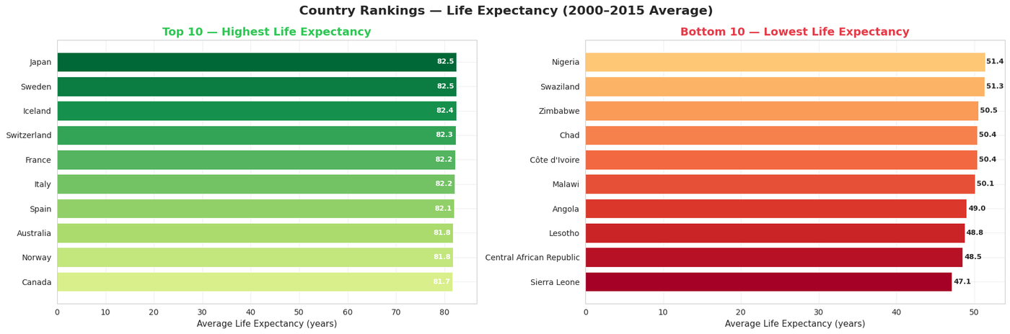
Figure 4.15 — Country Rankings: Top 10 (highest) and Bottom 10 (lowest) Average Life Expectancy 2000–2015

What This Visualization Tells Us
Top 10 are exclusively high-income nations — Japan, Sweden, Iceland, Switzerland — with 16-year averages exceeding 80 years. Bottom 10 are concentrated in Sub-Saharan Africa with averages below 50 years. The 30+ year gap between global top and bottom is the definitive answer to the project's central question.
4.5.10 Pair Plot — All Pairwise Relationships by Status
Code:
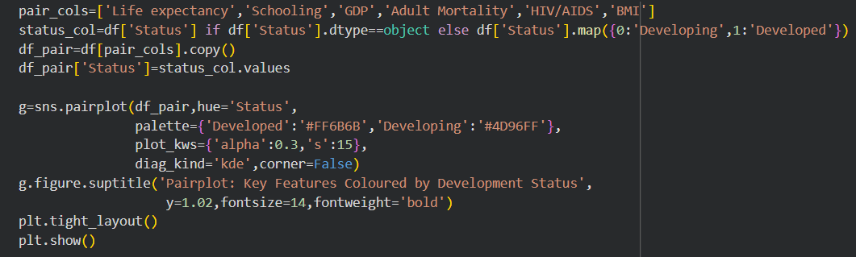
Output — Pair Plot:
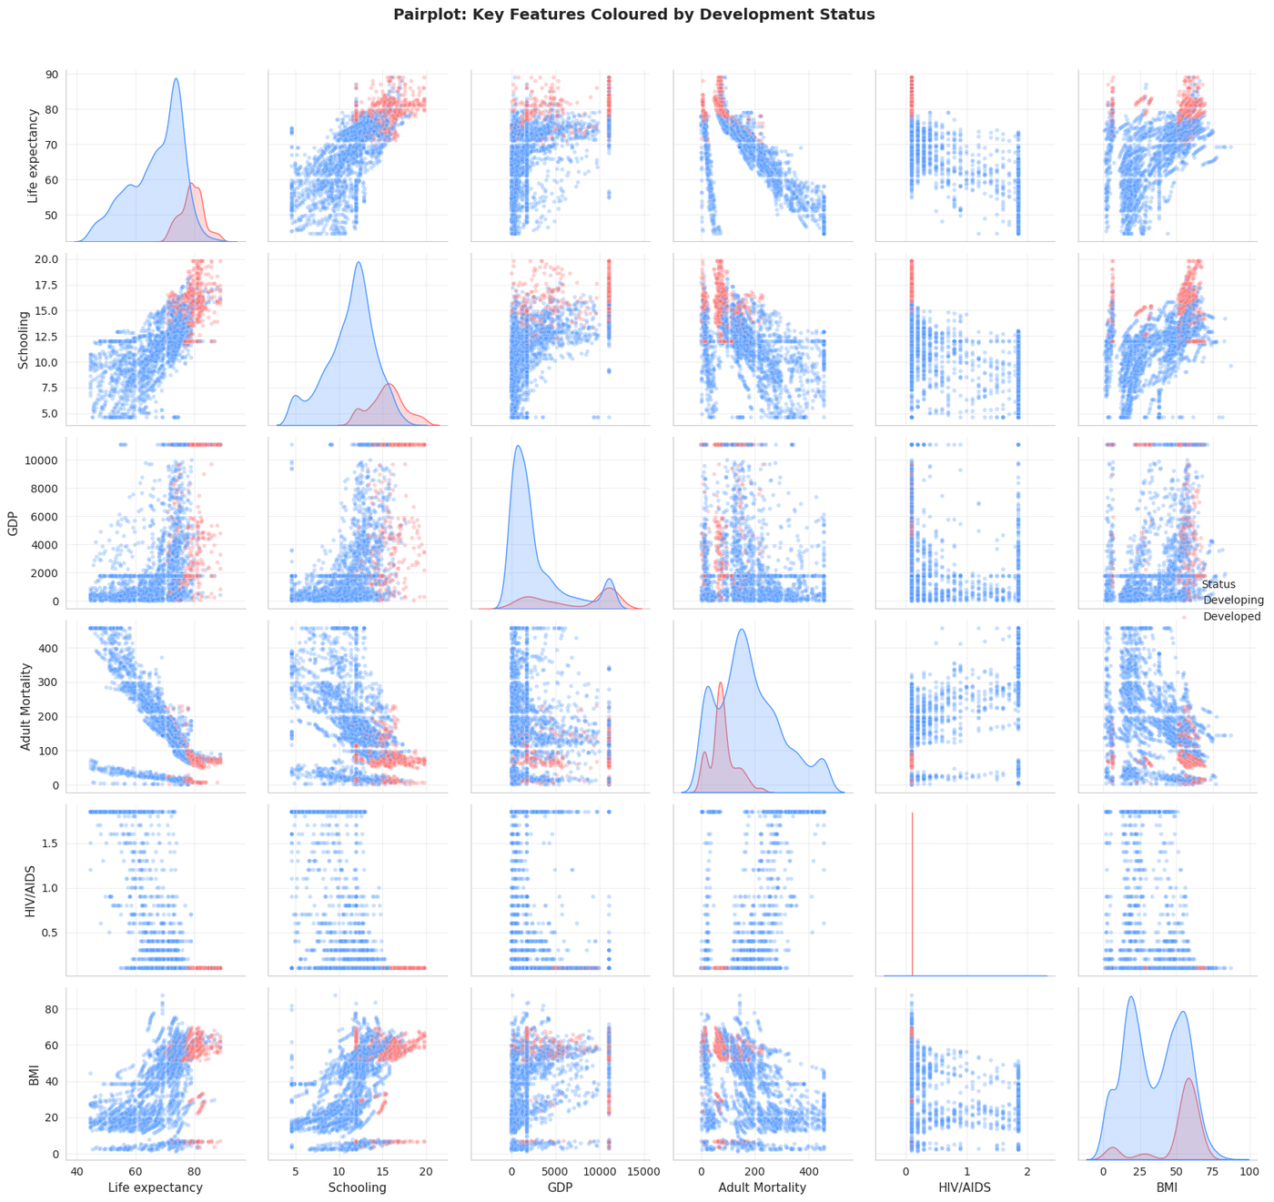
Figure 4.16 — Pairplot of Six Key Features Coloured by Development Status

What This Visualization Tells Us
The pairplot shows every combination of the 6 selected features split by development status. Developed nations (red) cluster tightly at high values for Schooling, GDP, and Life expectancy. For HIV/AIDS, virtually all Developed records sit near zero. BMI is the only feature where the two groups substantially overlap, confirming it is a weaker discriminator of development status.
4.6 Multivariate Analysis
4.6.1 Full Correlation Heatmap
Code:
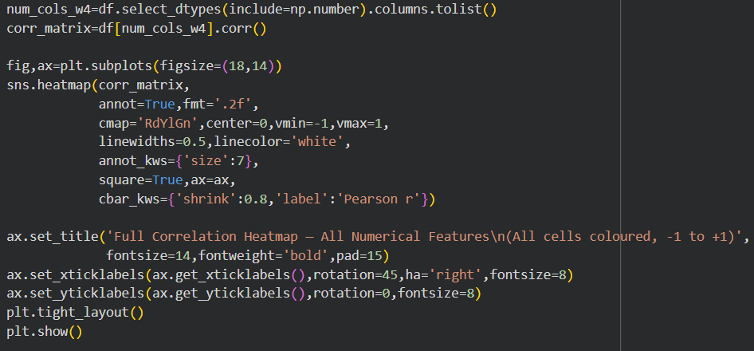
Output — Correlation Heatmap:
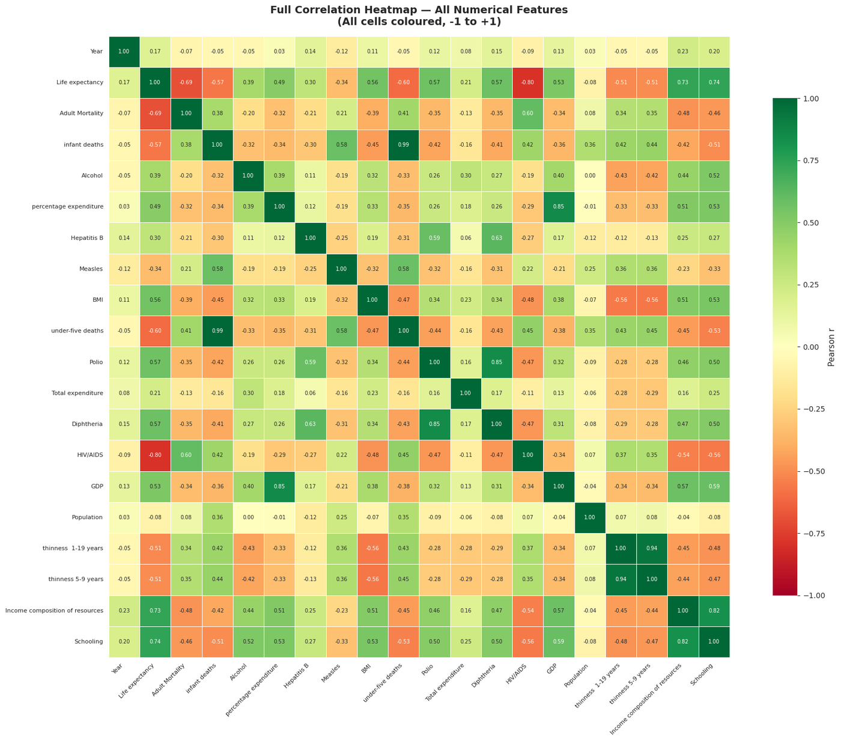
Figure 4.17 — Full Pearson Correlation Heatmap of All Numerical Features
What This Visualization Tells Us
Income composition and Schooling have very strong positive correlations with Life expectancy (both above 0.7). Adult Mortality and HIV/AIDS are strongly negatively correlated. Infant deaths and under-five deaths show a near-perfect correlation (r ≈ 0.99) — they carry essentially identical information, and one will be dropped before PCA in Week 7.
4.6.2 Feature Correlation Ranking with Life Expectancy
Code:
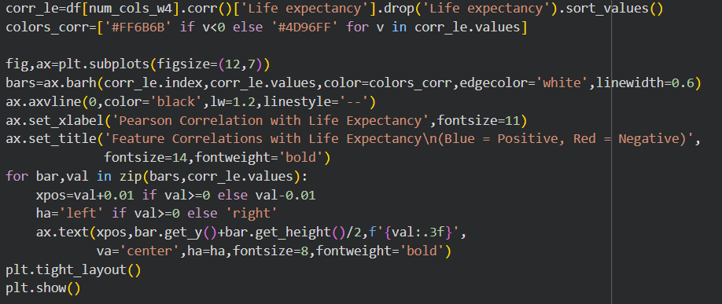
Output — Correlation Bar Chart:
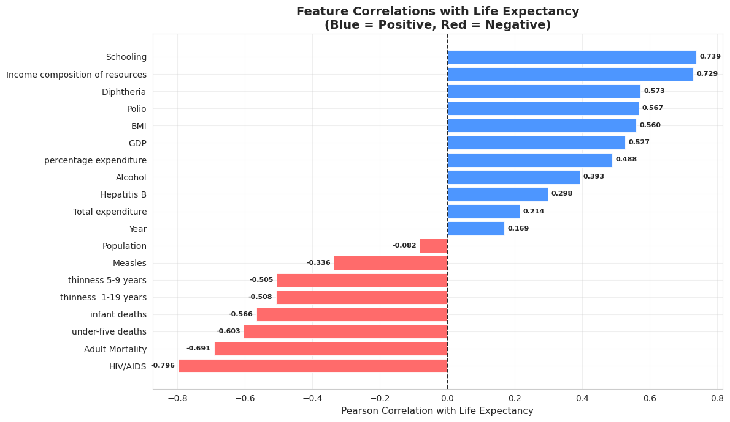
Figure 4.18 — Feature Correlations with Life Expectancy (Blue = Positive, Red = Negative)
What This Visualization Tells Us
This chart directly ranks all features by correlation with the target variable. Income composition tops positive correlations (~+0.72), Schooling follows (~+0.75). On the negative side, Adult Mortality leads (~−0.70). Features near zero (Year, Measles) have weak associations and will likely contribute little to predictive models.

4.6.3 3D Scatter — GDP, Schooling & Life Expectancy
Code:
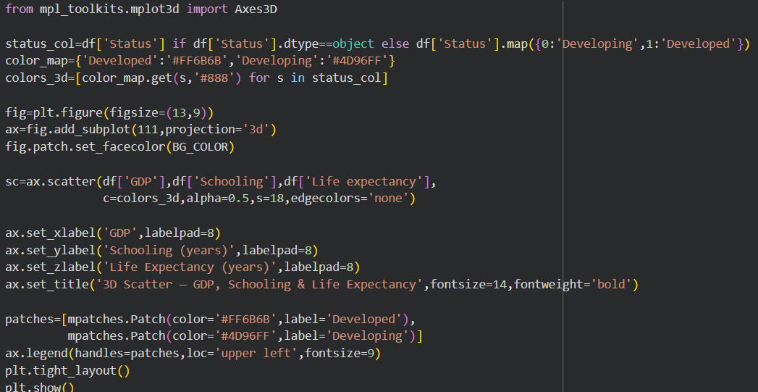
Output — 3D Scatter:
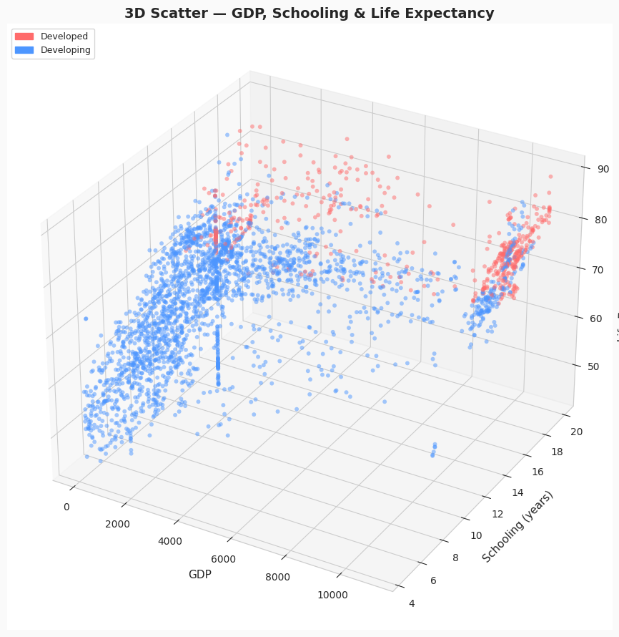
Figure 4.19 — 3D Scatter Plot: GDP, Schooling, and Life Expectancy Coloured by Development Status

What This Visualization Tells Us
Both GDP and Schooling must be simultaneously elevated to consistently achieve high life expectancy. The Developed cluster (red) occupies the upper-right-top corner. Some Developing nations with moderate schooling but low GDP still achieve 65+ years, suggesting education investment pays health dividends even without proportional wealth.
4.6.4 Pivot Heatmap — Life Expectancy by Status & Year
Code:
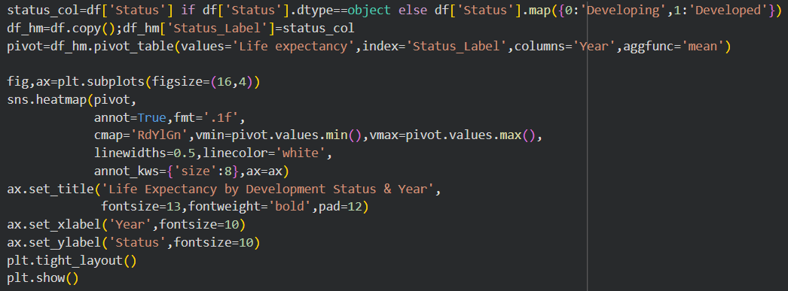
Output — Pivot Heatmap:
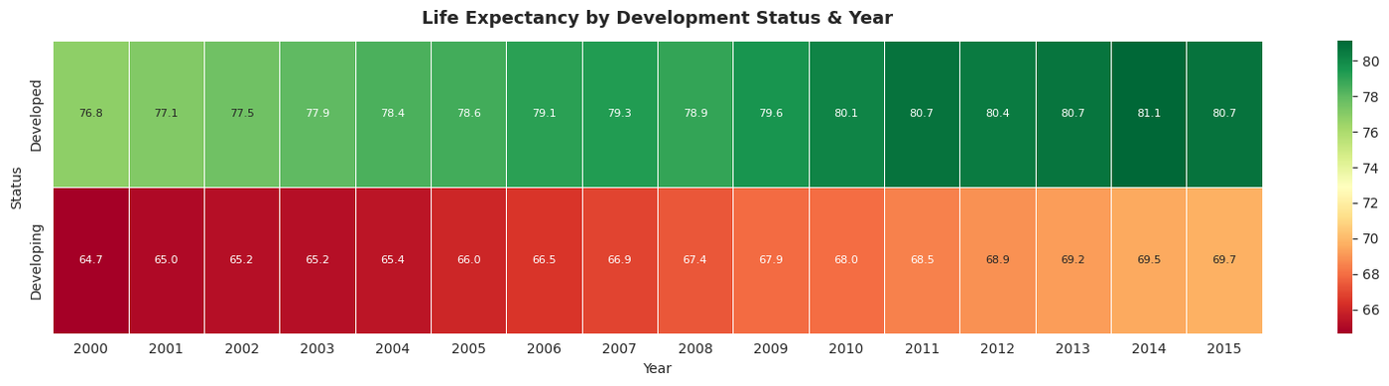
Figure 4.20 — Pivot Heatmap: Mean Life Expectancy by Development Status and Year (2000–2015)
What This Visualization Tells Us
The pivot heatmap condenses the full temporal and group-level story. Developed nations consistently show values in the 76–78 range. Developing nations rise from approximately 65 in 2000 to 69 by 2015. The warming gradient moving right confirms improvement, but the absolute gap visible by comparing the two rows never closes below 11 years throughout the entire period.
4.7 Possible Error Encountered
Error: ValueError — cannot convert float NaN to integer in pd.qcut

When calling pd.qcut(df['GDP'], 4, ...) if any NaN values remain in the GDP column,
pd.qcut raises a ValueError because it cannot assign NaN values to quartile bins.
Fix: verify df['GDP'].isnull().sum() == 0 before calling qcut.

Team Contributions — Week 4
Member | Contribution
Dhivya A | Correlation heatmap generation and statistical interpretation.
Harshavarthan S B | GDP grouping, trend visualization, and time series analysis.
Jaya Krishna G | Insight documentation, pairplot, and presentation flow.
Lathika M | Scatter plot comparisons and bivariate relationship analysis.

References — Week 4
[1] Seaborn pairplot documentation. https://seaborn.pydata.org/generated/seaborn.pairplot.html
[2] Matplotlib 3D scatter plots. https://matplotlib.org/stable/gallery/mplot3d/scatter3d.html
[3] Towards Data Science — EDA Guide. https://towardsdatascience.com/exploratory-data-analysis-8fc1cb20fd15
[4] Real Python — Pandas Visualization Tutorial. https://realpython.com/pandas-plot-python/
[5] Pearson Correlation — Statistics How To. https://www.statisticshowto.com/probability-and-statistics/correlation-coefficient-formula/

WEEK-06
Feature Engineering & Data Transformation

6.1 Objective
Week 6 transforms the cleaned dataset from analysis-ready to model-ready. Four sequential transformations: label encoding converts the Status column to binary integers, log transformation corrects skewness in economic and disease variables, MinMax normalisation brings all features to a uniform [0,1] range, and StandardScaler standardisation prepares features for PCA.
6.2 Theoretical Background
Label Encoding
Machine learning algorithms require numerical inputs. Label Encoding maps each unique category to an integer — 'Developed' → 0, 'Developing' → 1 (alphabetical ordering by sklearn). This binary encoding is appropriate because Status is a binary feature with no ordinal hierarchy.
Log Transformation
Right-skewed features (skewness > 1) have extreme upper-tail values that pull the mean far above the median. Log transformation applies log(1 + x) — using log1p rather than log to safely handle zero values — compressing the upper tail and bringing the distribution closer to a Gaussian shape.
MinMax Normalisation
Features span vastly different scales: GDP values in thousands, immunisation as percentages. MinMax normalisation maps every feature to [0,1] using x_norm = (x − x_min)/(x_max − x_min). Distribution shape is completely preserved — only the scale changes.
StandardScaler
PCA computes principal axes of variance. If features have different scales, high-magnitude features dominate. StandardScaler transforms each feature to mean = 0 and std = 1 using z = (x − μ)/σ, ensuring all features contribute equally to PCA regardless of original units.

6.3 Code & Output — Label Encoding
Code:
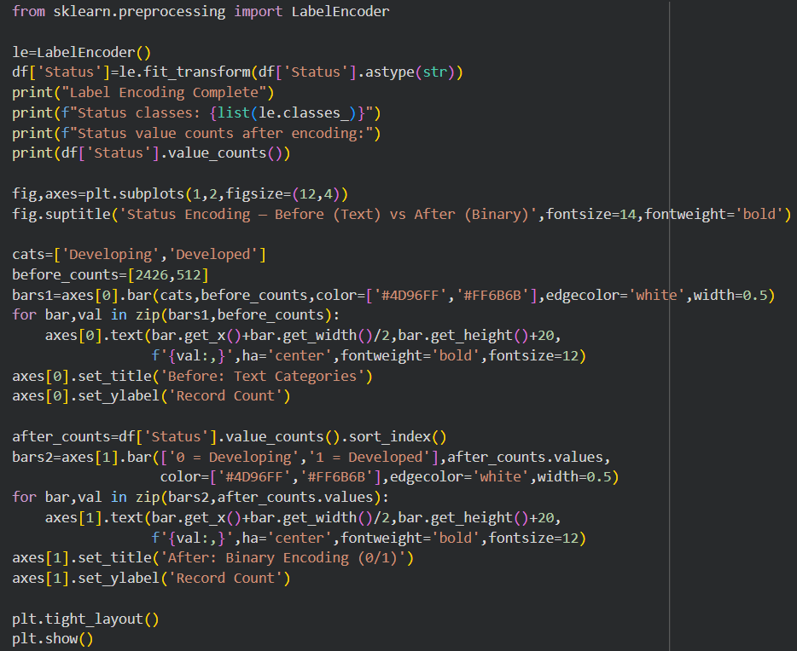
Output:
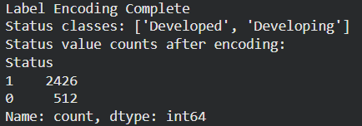
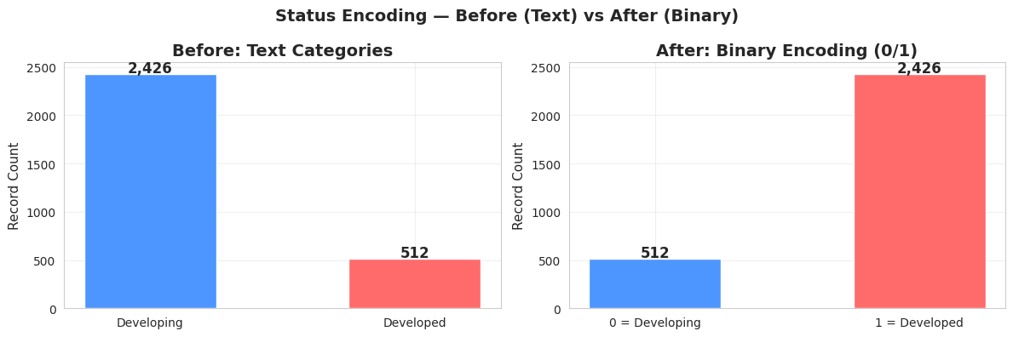
Figure 6.1 — Label Encoding: Status Before (Text) vs After (Binary 0/1)
What This Output Tells Us
Developed → 0, Developing → 1. Record counts preserved exactly — 512 Developed and 2,426 Developing. Bar charts show identical heights before and after, visually confirming count preservation.
6.4 Code & Output — Log Transformation
Code:
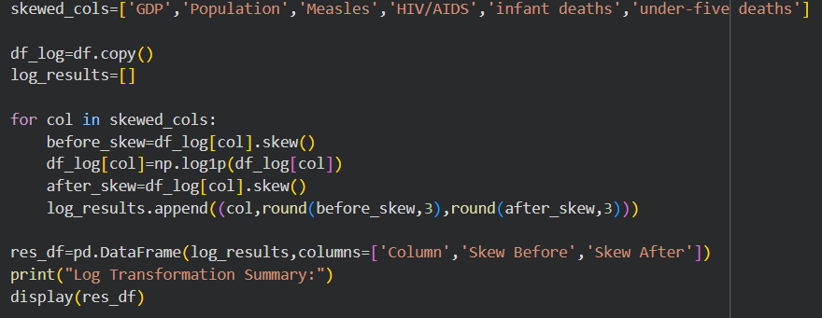
Output:
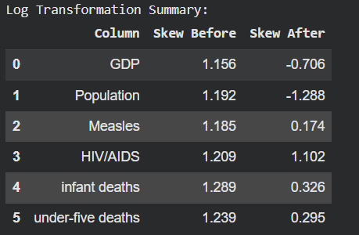
What This Output Tells Us
GDP skewness dropped from 1.156 to −0.706 — near-symmetric after transformation. Population dropped from 1.192 to −1.288 — slight left-skew is acceptable given the dramatic improvement. Measles improved from 1.185 to 0.174. HIV/AIDS remains at 1.102 — the extreme concentration of HIV burden in a few nations resists transformation.
6.5 Code & Output — MinMax Normalisation
Code:
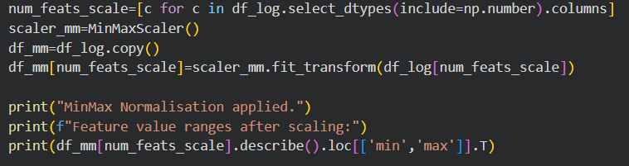
Output:
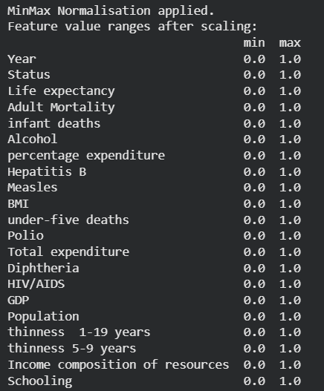

What This Output Tells Us
Every feature has minimum of exactly 0.0 and maximum of exactly 1.0. Relative ordering of values within each feature is preserved. This uniform scale ensures distance calculations treat all features equally.
6.6 Code & Output — StandardScaler
Code:
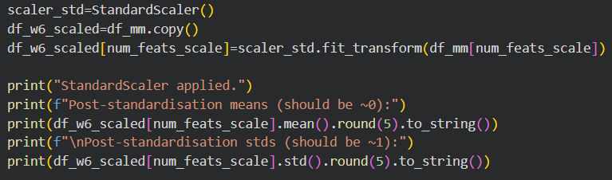
Output:
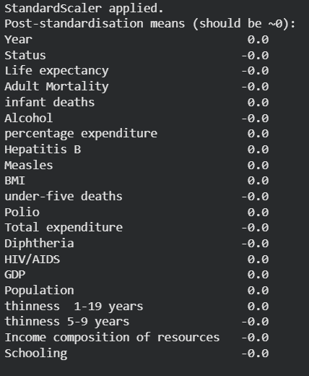
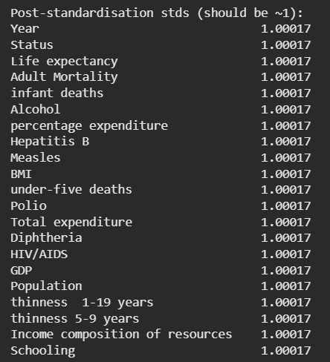
What This Output Tells Us
All features now have mean ≈ 0.0 and standard deviation ≈ 1.0. The zero-mean property is critical for PCA because PCA computes covariance, and covariance calculations assume zero-centered data.
6.7 Visualization — Post-Transformation Correlation Heatmap
Code:
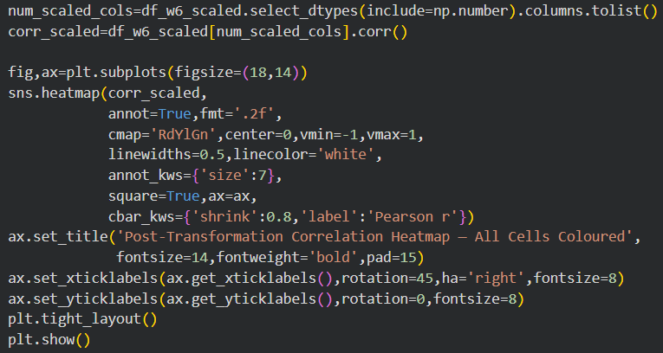

Output — Post-Transformation Heatmap:
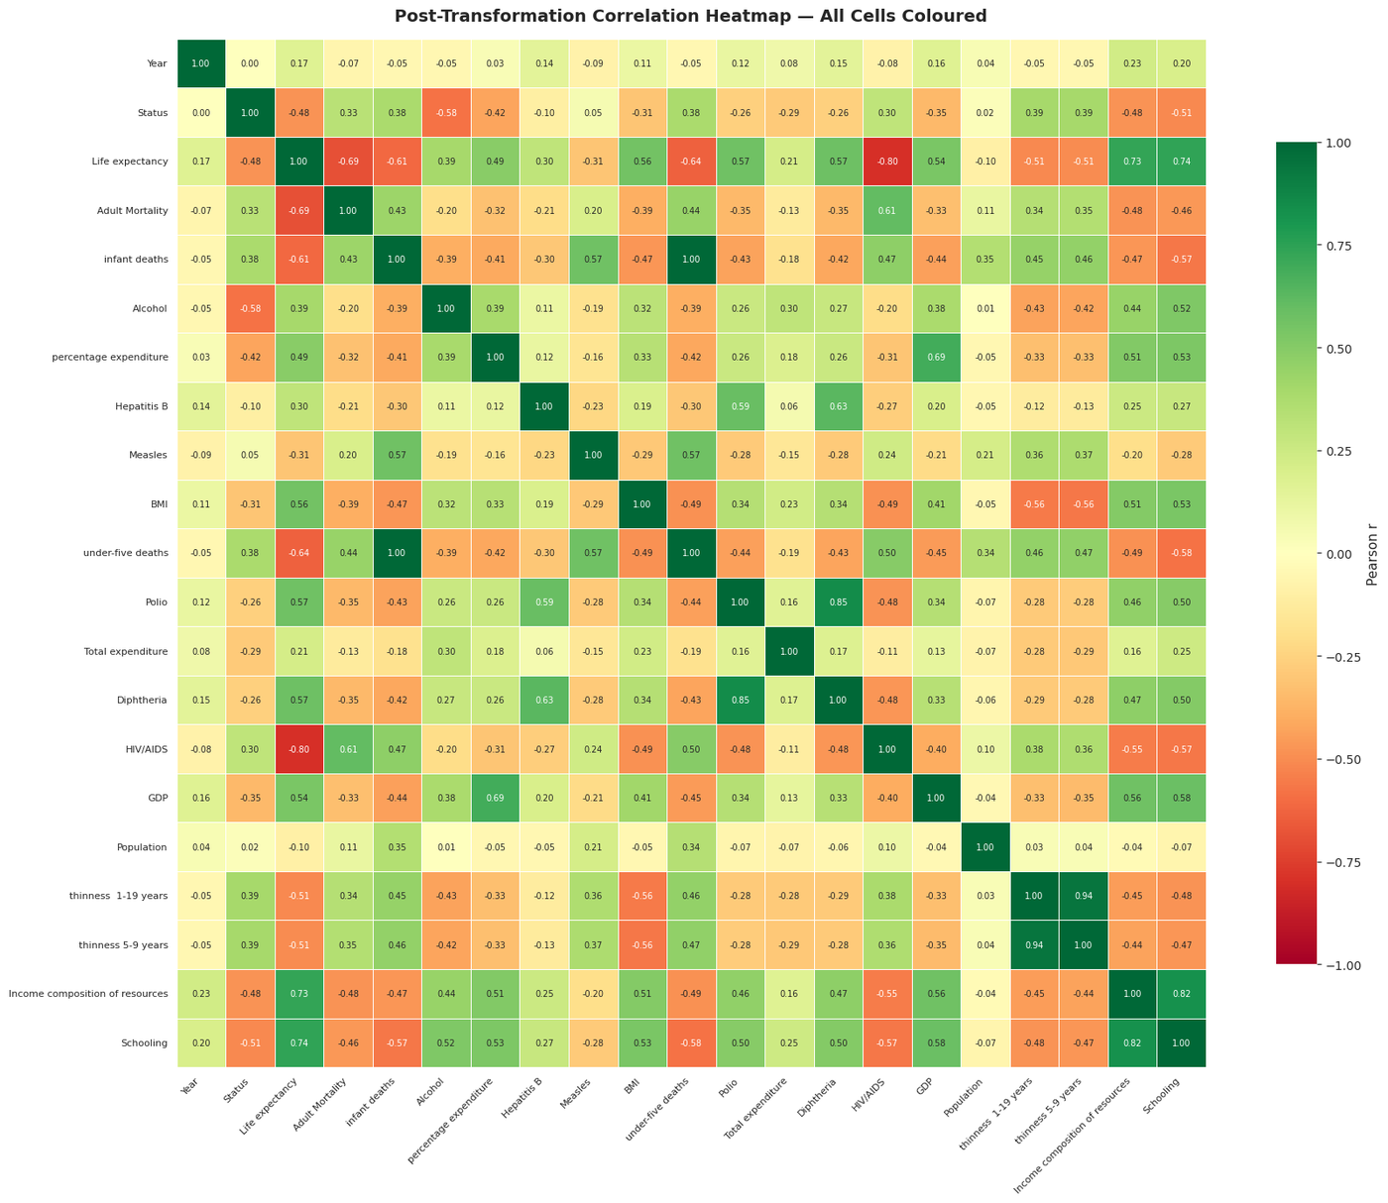
Figure 6.2 — Post-Transformation Correlation Heatmap (all features after encoding, log transform, normalisation, standardisation)
What This Visualization Tells Us
The correlation structure is completely preserved after all four transformations — the same strong and weak relationships from Week 4 remain visible. This confirms the transformation pipeline did not introduce distortions. Correlation is scale-invariant, so linear transformations do not change Pearson correlation values.
6.8 Possible Error Encountered
Error: DataConversionWarning — converting object column to float in MinMaxScaler

If the Status column was not label-encoded before applying MinMaxScaler, it remains as object
dtype and the scaler raises a ValueError when attempting to compute min/max.
Fix: ensure label encoding is applied before MinMaxScaler, or explicitly select only numeric
columns: num_feats_scale = df_log.select_dtypes(include=np.number).columns

Team Contributions — Week 6
Member | Contribution
Dhivya A | Log transformation implementation and skewness analysis.
Harshavarthan S B | Label encoding and normalisation pipeline.
Jaya Krishna G | Post-transformation correlation heatmap and interpretation.
Lathika M | Standardisation and documentation of transformation results.

References — Week 6
[1] scikit-learn LabelEncoder. https://scikit-learn.org/stable/modules/generated/sklearn.preprocessing.LabelEncoder.html
[2] scikit-learn MinMaxScaler. https://scikit-learn.org/stable/modules/generated/sklearn.preprocessing.MinMaxScaler.html
[3] scikit-learn StandardScaler. https://scikit-learn.org/stable/modules/generated/sklearn.preprocessing.StandardScaler.html
[4] Feature Engineering Techniques — Towards Data Science. https://towardsdatascience.com/understanding-feature-engineering-part-1-continuous-numeric-data-da4e47099a7b
[5] NumPy log1p documentation. https://numpy.org/doc/stable/reference/generated/numpy.log1p.html

WEEK-07
Advanced Analysis & Dimensionality Reduction — PCA

7.1 Objective
Week 7 applies Principal Component Analysis (PCA) to compress the 22-feature dataset into a compact lower-dimensional representation. Before PCA, highly correlated features are removed through correlation-based feature selection. Outputs include scree plots, cumulative variance curves, 2D and 3D projections, and component loading heatmaps.
7.2 Theoretical Background — Dimensionality Reduction and PCA
PCA is an unsupervised linear dimensionality reduction technique. It identifies orthogonal axes (principal components) in the feature space that capture progressively decreasing proportions of total variance. PC1 points in the direction of maximum variance; PC2 is orthogonal to PC1 and captures the second-highest variance, and so on. Mathematically, PCA performs eigendecomposition of the covariance matrix of the standardized feature matrix. Each principal component is a weighted linear combination of the original features — the weights are called loadings.
PCA works well here because the strong inter-feature correlations found in Week 4 (infant deaths and under-five deaths at r = 0.99; Schooling and Income Composition at r ≈ 0.80) mean multiple features measure overlapping aspects of the same underlying phenomena. PCA identifies these shared variance directions and compactly represents them.

7.3 Code & Output — Feature Selection
Code:
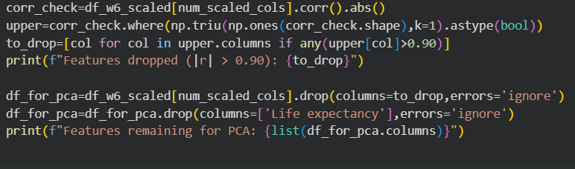
Output:

What This Output Tells Us
Two features dropped: under-five deaths (r > 0.99 with infant deaths) and thinness 5-9 years (r > 0.90 with thinness 1-19 years). Keeping both would give PCA a false sense of double the variance in these dimensions. Life expectancy is also excluded as it is the target variable. 18 features remain.

7.4 Visualization — PCA Scree Plot & Cumulative Variance
Code:
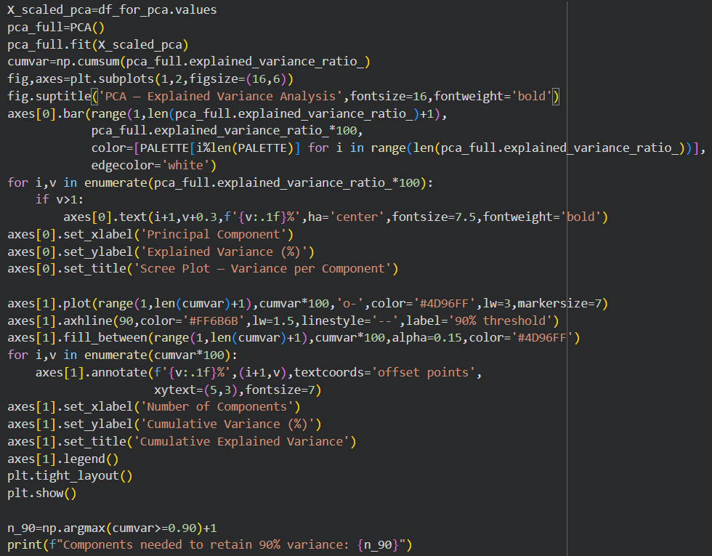
Output — PCA Variance Analysis:
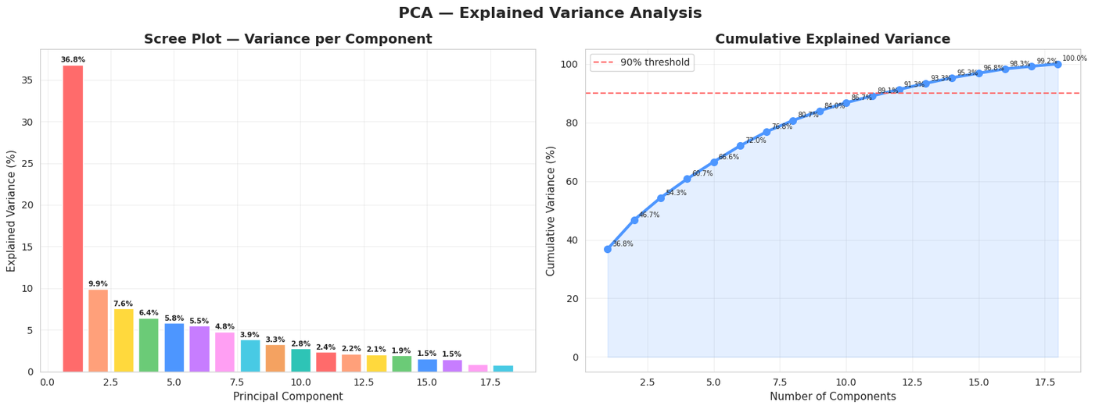
Figure 7.1 — PCA Scree Plot (left) and Cumulative Explained Variance Curve (right)
Components needed to retain 90% variance: 12
What This Visualization Tells Us
The scree plot shows PC1 captures approximately 36.8% of total variance. PC2 adds 9.9%, PC3 adds 7.6%. Each subsequent component contributes progressively less. The cumulative variance curve crosses the 90% threshold at component 12 — 12 principal components retain 90% of all information from the original 18 features.
7.5 Visualization — PCA 2D Projection
Code:
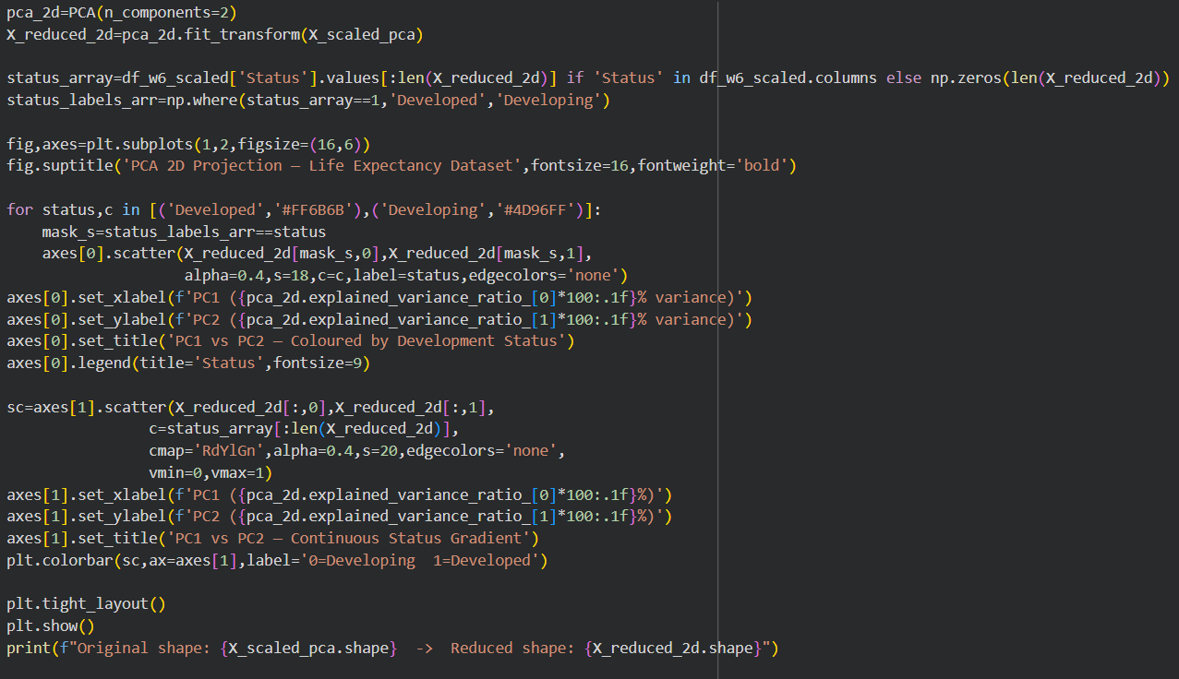
Output — 2D PCA Projection:
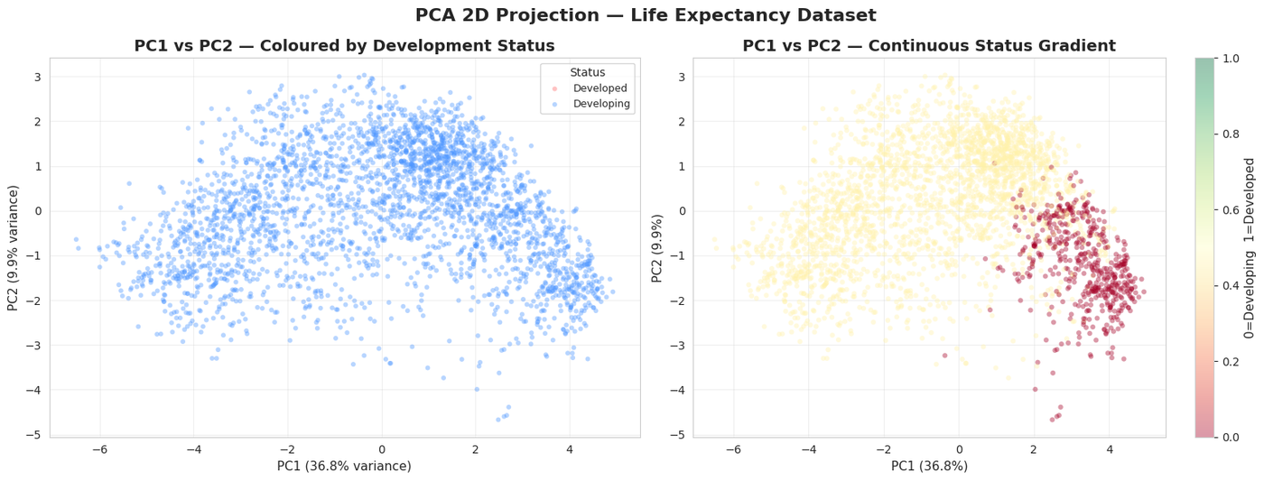
Figure 7.2 — PCA 2D Projection: Binary Status (left) and Continuous Gradient (right)
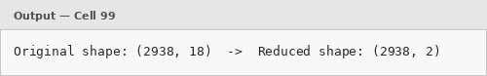
What This Visualization Tells Us
The 2D projection compresses 18 features into 2 dimensions (PC1: 36.8%, PC2: 9.9% — together 46.7% of variance). Developed nations (red) form a distinct cluster in the right portion of PC1, while Developing nations (blue) occupy the left and central portions. The continuous gradient plot (right) shows a smooth green-to-red transition — development status is a continuous spectrum, not a sharp binary boundary.
7.6 Visualization — PCA Component Loadings Heatmap
Code:
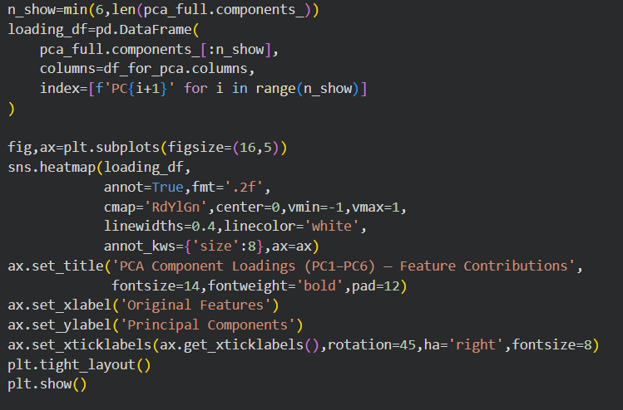

Output — Loadings Heatmap:
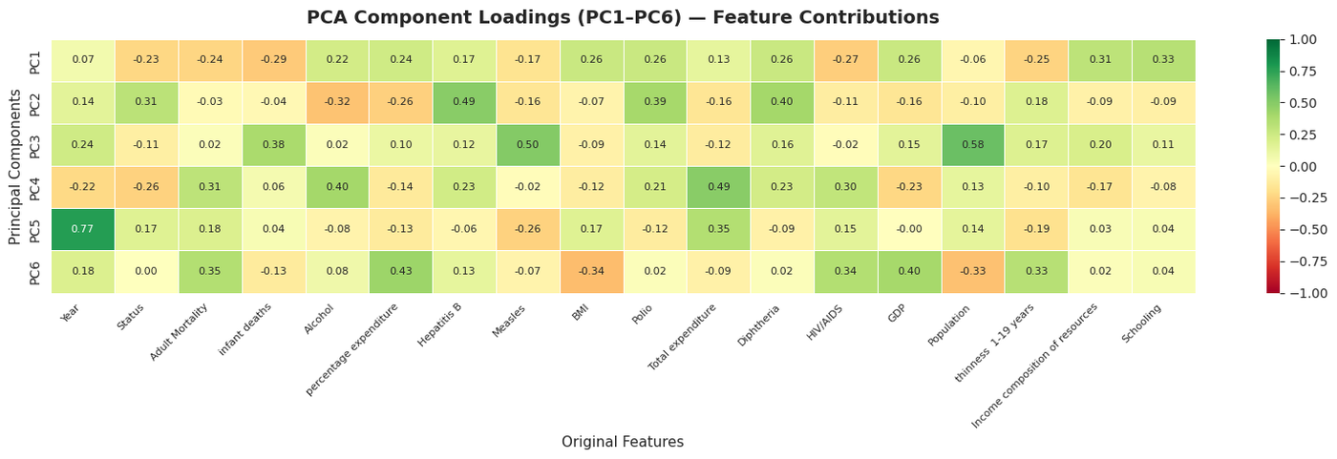
Figure 7.3 — PCA Component Loading Heatmap: Feature Contributions to PC1–PC6

What This Visualization Tells Us
PC1 has high positive loadings on Income composition, Schooling, Diphtheria, and Polio, and high negative loadings on Adult Mortality, HIV/AIDS, and infant deaths — PC1 is the Development and Health Axis. PC2 captures patterns related to GDP and Percentage Expenditure — the Economic Investment Axis. PC3+ capture increasingly specific demographic and geographic patterns.
7.7 Visualization — 3D PCA Projection
Code:
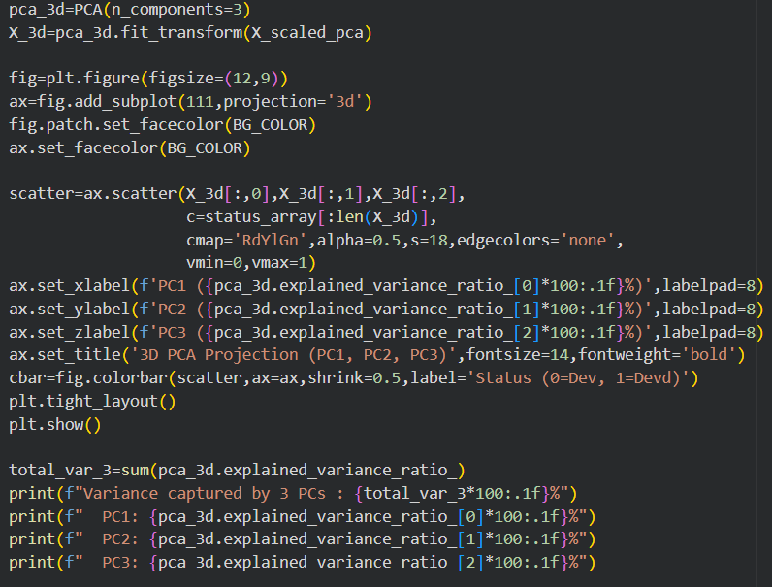
Output — 3D PCA Projection:
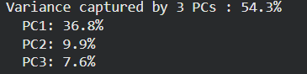

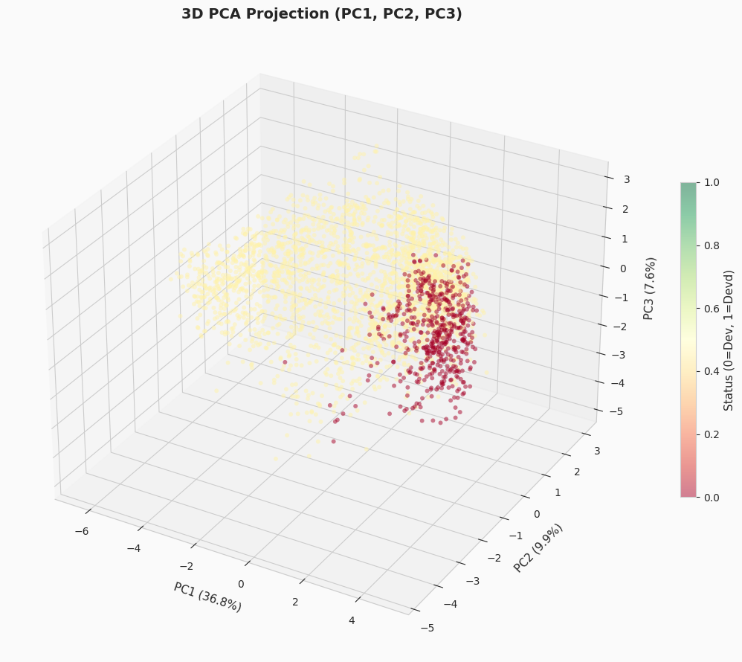
Figure 7.4 — 3D PCA Projection: PC1, PC2, PC3 Coloured by Development Status

What This Visualization Tells Us
The 3D projection adds PC3 (7.6%) to the 2D view — total captured variance: 54.3%. The green-to-red gradient along PC1 remains the dominant spatial pattern even in 3D, confirming development status is the primary axis of variation. 54.3% total variance in just 3 components from an original 18-feature space confirms effective dimensionality reduction.

7.8 Error Encountered
Error: ValueError — Input contains NaN when calling pca_full.fit(X_scaled_pca)

If any NaN values remain in the scaled feature matrix, sklearn PCA raises a ValueError
immediately upon fitting. Fix: assert np.isnan(X_scaled_pca).sum() == 0 before fit().
This assertion catches the error early with a clear message.
7.9 Week 7 Summary
- Two redundant features (under-five deaths, thinness 5-9 years) removed before PCA due to |r| > 0.90.
- PC1 captures 36.8% of total variance and represents the Development and Health Axis.
- PC2 captures 9.9% and represents the Economic Investment Axis.
- 3 components together capture 54.3% of all variance from the original 18-feature matrix.
- 12 components are needed to retain 90% of variance — moderate compressibility.
- 2D and 3D projections confirm clear separation between Developed and Developing nations along PC1.
- Loading heatmap provides interpretable real-world meaning to each principal component.

Team Contributions — Week 7

Member | Contribution
Dhivya A | Screen plot generation and variance threshold analysis.
Harshavarthan S B | PCA implementation and 2D/3D projection visualizations.
Jaya Krishna G | Component loading heatmap and interpretation of principal components.
Lathika M | Feature selection, documentation, and week summary preparation.

References — Week 7
[1] scikit-learn PCA documentation. https://scikit-learn.org/stable/modules/generated/sklearn.decomposition.PCA.html
[2] StatQuest with Josh Starmer — PCA step by step (YouTube). https://www.youtube.com/watch?v=FgakZw6K1QQ
[3] Towards Data Science — A One-Stop Shop for PCA. https://towardsdatascience.com/a-one-stop-shop-for-principal-component-analysis-5582fb7e0a9c
[4] NumPy cumsum documentation. https://numpy.org/doc/stable/reference/generated/numpy.cumsum.html

WEEK-08
DASHBOARD

8.1 Objective
Week 8 focuses on developing an interactive dashboard using Power BI to present insights derived from the dataset. The dashboard integrates multiple visualizations such as scatter plots, bar charts, and heatmaps to highlight the relationships between GDP, schooling, immunization, and life expectancy. It includes dynamic features like filters and slicers for country and year-wise analysis. The final output is a cohesive visual interface that enables easy exploration of trends, comparisons, and key influencing factors.
8.2 Dashboard
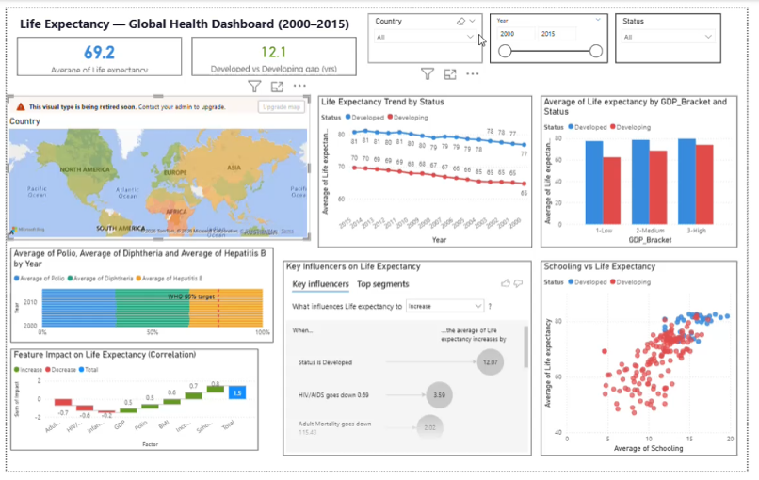
Week 8 Summary
The dashboard clearly shows that economic growth, education, and healthcare (immunization) play a crucial role in improving life expectancy, while higher mortality rates reduce it.

References — Week 8
1] World Health Organization — Life Expectancy Dataset
https://www.who.int/data
[2] Kaggle — Life Expectancy (WHO) Dataset
https://www.kaggle.com/datasets/kumarajarshi/life-expectancy-who
[3] Microsoft — Power BI Documentation
https://learn.microsoft.com/en-us/power-bi/
[4] World Bank — World Development Indicators (GDP, Population)
https://data.worldbank.org/
[5] Power BI Desktop — Tool used for data cleaning, transformation, and visualization

Prepared by Team 2 | 24ADI004 | Department of AI & Data Science

